
  - Water Management Plan For the control of Legionella

Developing a comprehensive Water Management Plan (WMP) for the control of Legionella in a long-term care facility is a critical step in patient and resident safety, as these facilities house a highly susceptible population.
The plan should be a living document, following a framework like the one outlined in ASHRAE Standard 188 and recommended by the CDC.

  - Water Management Plan For the control of Legionella

The following pages are templates based on those established best practices, to be customized to your facility's specific water system and risks.
Water Management Plan For the control of Legionella


Water Management Plan For the control of Legionella

[Facility Name] Water Management Plan
Address: _________________________________________
_________________________________________
Date Water Management Plan Created: ____________
Date of Last Review/Revision: ______________________

Section 1: Water Management Team
The WMP Team is responsible for the development, implementation, and ongoing management of this plan.

Team Members

Role/Function | Name  Contact Information (Phone/Email) | Primary Responsibilities
WMP Leader/Program Champion | [Name]  [Contact Info] | Final authority, plan oversight, liaison to administration.
Infection Preventionist | [Name]  [Contact Info] | Monitoring resident/patient cases, clinical-environmental link.
Maintenance/Facilities Engineer | [Name]  [Contact Info] | System maintenance, monitoring, implementing corrective actions.
Water Treatment Specialist (External) | [Name]  [Contact Info] | Consult on water quality, treatment, and testing protocols.
Administrator/Risk Management | [Name]  [Contact Info] | Resource allocation, policy, and regulatory compliance.
Nursing/Clinical Representative | [Name]  [Contact Info] | Input on resident care practices and high-risk areas.
Other (e.g., Housekeeping, Security) | [Name]  [Contact Info] | Specific tasks (e.g., flushing, documentation).

Section 2: Building and Water System Description
A detailed description of the facility and its water system is necessary to identify potential hazard areas.

Facility Characteristics:

Building Type: | □ Long Term Care □ Skilled Nursing Facility □ Other
Year Built: | Updated: | Updated: | Updated:
Water Source: | Municipal | Well | Other:
Water Utility Company: | Name | Address | Ph:
Disinfection: | Chlorine Monochloramines  Other | No Disinfection  UV  Other | Specify:
High-Risk Patient Population: | Location: | Location: | Location:
Recent/Planned Construction/Renovations: | Yes | No | If yes, specify

Water System Components & Flow Diagram
- Required Documentation:
    - Written Water System Narrative
    - System Process Flow Diagram (Attach as Appendix A)
- Include:
  - Incoming water line
  - backflow prevention
  - water heaters
  - water storage tanks
  - Water softeners
  - booster pumps
  - distribution piping: Recirculation, risers, flow/return direction, distal points
  - thermostatic mixing valves (TMVs)
  - high-risk devices:

Inventory of High-Risk Water Devices (Aerosol-Generating)

Device/System | Location | Operating Temperature/Settings | Maintenance Frequency/Schedule
Hot Water Tanks/Heaters |  | ⁰F - ⁰F
Cooling Towers (If applicable) |  | N/A
Hot Tubs/Spas (If applicable) |  | ⁰F - ⁰F
Device/System | Location | Operating Temperature/Settings | Maintenance Frequency/Schedule
Decorative Fountains/Water Features |  | N/A
Misting/Humidification Systems |  | N/A
Emergency Eye Wash Stations |  | N/A
Dead Legs/Low-Flow Areas/Unoccupied/Low Use areas |  | N/A

Section 3: Hazard Analysis and Critical Control Points (CCP)
Identify points in the system where Legionella growth is likely and define control measures.

Water System/Location | Potential Hazard/Risk Factor | Critical Control Point (CCP) | Control Limit (Acceptable Range)
Hot Water Distribution | Water temperature in F⁰ - F⁰ range | Hot water outlet temperature at distal points | F⁰ - F ⁰at distal points (resident areas)
Water System/Location | Potential Hazard/Risk Factor | Critical Control Point (CCP) | Control Limit (Acceptable Range)
Hot Water Heater/Storage | Water heater temperature too low | Hot water heater set point | F⁰ - F ⁰
Thermostatic Mixing Valves (TMVs) | Tepid water temperature | TMV output temperature (after mixing) | F⁰ - F ⁰ for resident use
Cold Water Lines | Low disinfectant residual | Cold water residual disinfectant | Specify value e.g. 0.1 mg/L chlorine
Low-Flow Fixtures/Dead Legs | Water stagnation | Fixture/Outlet flushing activity | Scheduled flushing (e.g., day/time >5 minutes)

Section 4: Monitoring and Corrective Actions
Define the maximum and minimum limits for each Control Point

CCP/Parameter | Location(s) to Monitor | Frequency | Procedure/Method | Who is Responsible
Hot Water Temperature | Hot Water Heater Outlet Distal  High-Risk Fixtures | Daily/Weekly | Thermometer (Record on Log Form) | [Team Member]
Cold Water Disinfectant Residual | Main Incoming Line  Distal  High-Risk Fixtures | Daily/Weekly | Chemical Test Kit (Record on Log Form) | [Team Member]
CCP/Parameter | Location(s) to Monitor | Frequency | Procedure/Method | Who is Responsible
TMV Temperature | TMV Output (Selected Valves) | Monthly/  Quarterly | Thermometer (Record on Log Form) | [Team Member]
Flushing of Low-Use Fixtures | Unoccupied Rooms, Low Use Areas/ Emergency Fixtures | Weekly/  Monthly | Run water for 5 minutes (Record on Log Form) | [Team Member]

Corrective Actions
Define the required action when a control limit is exceeded.

Control Limit Exceeded (Trigger) | Corrective Action(s) | Responsible Party | Documentation Required
Hot water at a distal tap  < \ ⁰F- ⁰F | Immediately investigate cause.  Adjust water heater/TMV. Initiate localized flush\disinfection. | Facilities/Maintenance | Corrective Action Log
Cold water disinfectant residual too low | Notify WMP Team Leader. Increase disinfectant (if supplemental). System shock disinfection. | WMP Leader/Water Specialist | Corrective Action Log
Confirmed (clinical) case of Legionnaires' disease | Notify local/state health dept. Begin Outbreak Response Plan (see Appendix C). | WMP Leader/Infection Control | Incident Report, Response Log

Section 5: Response to Confirmed Legionella Case(s)
Trigger: __ Single confirmed case __ Cluster of cases

Procedure:
- Immediately notify the local/state public health department.
- Implement the facility's Outbreak/Contingency Response Plan (Attach as Appendix C).
- Restrict use of water sources suspected of contamination.
- Conduct environmental sampling (see Section 6).
- Implement remediation/disinfection of the water system.

Section 6: Verification and Validation
Verification ensures the program is being implemented as written.
Validation confirms the program is effective in controlling the risk.

Program Verification:
- Activity: Review monitoring logs, maintenance records, and corrective action documentation.
- Frequency: [Monthly/Quarterly]
- Responsible: WMP Leader/Team
Program Validation (Environmental Testing):
Strategy:
- Routine testing: Frequency:
- Testing only in response to a case/outbreak
- Other: [Specify]
Sampling Locations:
  - High-risk
  - Distal sites
  - High-use showers
  - Thermostatic Mixing Valves
- Testing Protocol: Follow a recognized standard (e.g., CDC/ASHRAE).
Firm samples are sent to: _______________
- Acceptable Limit:
Specify acceptable culture or PCR results: __________
- Action for Positive Results:
- Trigger defined corrective action plan (see Section 4).

Section 7: Documentation and Training
All activities must be documented and records maintained for [Specify Duration]; All personnel involved in the WMP must be trained on their specific duties.

Documentation:

- WMP Team meeting minutes.
- Water system flow diagrams and narratives.
- Monitoring Logs
  - Temperature
  - pH
  - Disinfectant Residual
  - Flushing
- Corrective Action Logs
- Training records
- Environmental testing results
Training:

- Target Audience: WMP Team, Facilities Staff, Nursing Staff.
- Frequency:
  - Initial Training
  - Annual Refresher
- Topics:
  - Legionella risk
  - WMP procedures
  - Monitoring techniques
  - Documentation
  - Infection prevention measures.
Appendices (Checklist for Required Attachments)

- Appendix A: Water System Process Flow Diagram and Written Narrative

- Appendix B: Monitoring Log Forms (Temperature, Disinfectant/pH, Flushing, templates provided)

- Appendix C: Outbreak/Contingency Response Plan (Remediation Procedures)

- Appendix D: Team Roster with Signatures/Sign-Off

WMP Team Leader Signature: _________________________ Date: _____________

Administrator Signature: _________________________ Date: _________________

  - Water Management Plan For the control of Legionella

Documentation Templates:
Creating a successful water management plan requires meticulous record-keeping. Here are three log forms designed for monthly monitoring of temperature, disinfectant, and flushing activities.
You can copy and use these as templates for your facility's documentation.

1. Hot Water Temperature Monitoring Log
This log is used to monitor and document hot water temperatures at critical control points (CCPs) throughout the distribution system to ensure temperatures are maintained above the Control Limit for Legionella growth (114-120⁰F at distal points and 125-160⁰F at the water heater).

Facility Name: __________________
Location/Zone: [e.g., East Wing] ________________
Month/Year: _________________
Date | Time | Fixture Type (e.g., Shower, Sink) | Hot Water Heater Outlet (Target __ ⁰F) | Distal Fixture Temperature  (Target __ ⁰F) | Corrective Action Taken (If N) | Initials
1st
2nd
3rd
4th
5th
6th
7th
8th
9th
10th
11th
12th
13th
14th
15th
16th
17th
18th
19th
20th
21st
22nd
23rd
24th
25th
26th
27th
28th
29th
30th

Reviewer Signature: _________________________ Date of Review: ____________

2. Disinfectant Residual Monitoring Log
This log documents the disinfectant residual (e.g., chlorine, chloramine) in the cold and hot water systems to ensure adequate chemical protection against microbial growth.

Facility Name: _______________________
Disinfectant Type: [e.g., Chlorine] __________
Control Limit: [e.g., ≥ 0.2 mg/L] _______________
Month/Year: _________________________________

Date | Time | Location Monitored (e.g., Water Entry Point, Distal Cold Tap) | Total Residual Reading (mg/L or ppm) | Control Limit Met? (Y/N) | Corrective Action Taken (If N) | Initials
1st
2nd
3rd
4th
5th
6th
7th
8th
9th
10th
11th
12th
13th
14th
15th
16th
17th
18th
19th
20th
21st
22nd
23rd
24th
25th
26th
27th
28th
29th
30th

Reviewer Signature: _________________________ Date of Review: _______________________

3. Water Stagnation (Flushing) Log
This log tracks the scheduled flushing of low-flow or non-occupied areas to prevent water stagnation, a key condition for Legionella growth. Flushing should be done for a minimum duration to exchange the water in the line (e.g., {≥5} minutes).

Facility Name: [Insert Name] | Flushing Protocol: Run until consistent temperature is reached or a minimum of [e.g., 5] minutes.  Frequency: every 3-5 days | Month/Year:

Date | Time | Location Monitored (e.g., Room #101 Sink, Employee Breakroom Ice Machine, Beauty Shop sink) | Fixture Type | Water Temperature at Start ⁰F | Water Temperature at End ⁰F | Flushing Duration (Minutes) | Initials

Reviewer Signature: _________________________ Date of Review: _______________________

Appendix A: Building Water System Mapping Template
I. General Building & System Information
This section documents the buildings characteristics.
Field | Detail
Building Name/ID
Building Address
Date of Map Creation/Update
Prepared By
Purpose of Map | (e.g., Water Safety Plan, Maintenance, Legionella Risk Assessment)
Source of Water | (e.g., Municipal, Well, Rainwater Harvesting)
Primary Utility/Supplier
System Classification | (e.g., Potable, Non-Potable, Heating/Cooling)

II. Water Inlet & Main Components
This section documents where water enters the building and the primary treatment/storage components.
Component | Location (Room/Floor) | Material (Pipe/Tank) | Volume/Capacity | Operating Temperature | Notes (Treatment/Filters/Maintenance) | Date of installation
Water Service Line Entry |  |  | N/A | Ambient
Water Meter |  |  | N/A | N/A
Backflow Prevention Device |  |  | N/A | N/A | (Type, Test Date)
Main Shut-off Valve |  |  | N/A | N/A
Water Storage Tank(s) |  |  |  |  | (Lid/Vent condition, cleaning schedule)
Water Heater(s) |  |  |  |  | (Set point \degree ⁰F, Circulation details)
Water Softener/Treatment |  |  |  |  | (Chemicals used, Backwash frequency)
Booster Pump(s) |  |  |  |  | (Operating pressure)
Other Major Component
III. Distribution System - Risers and Zones
Map the vertical (risers) and horizontal distribution, often segmented by floors or wings (zones).
Riser/Zone ID | Start Point | End Point | Serving Floors/Areas | Pipe Material | Pipe Diameter | Notes (Dead-legs, Future isolation points)
Riser 1 (Cold Water)
Riser 2 (Hot Water)
Zone A - Ground Floor
Zone B - Wing 1

IV. Point-of-Use Fixtures and Outlets
Document specific high-risk or critical outlets.
Outlet ID | Location (Room/Area) | Type of Fixture | Last Flushing/Use Date | Measured Temperature \degree C | Notes (Condition, Aerator, Usage)
V. Schematic Drawing and Key
Include a visual diagram, which is the most critical part of a water map.
Schematic Drawing Notes
- Attach a detailed drawing showing the physical layout, flow direction, and component locations (from Section II).
- Use standard plumbing symbols.
- Clearly label all risers, zones, storage tanks, heaters, and main valves (using IDs from Sections II and III).
- Indicate known dead-legs, low-flow areas, and cross-connections.

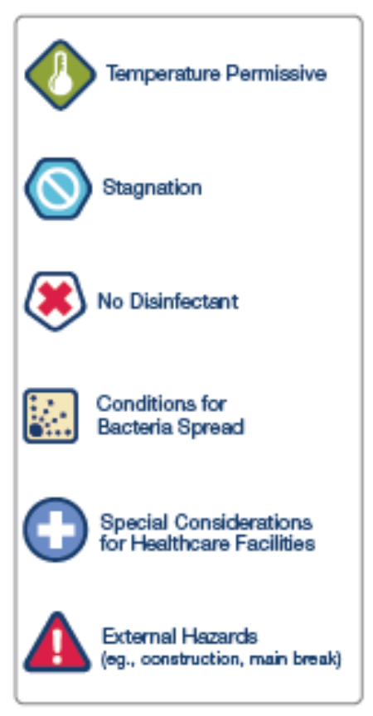
Key/Legend
Symbol/Color | Meaning
Arrow | Water Flow Direction
CW (Blue Line) | Cold Water Line
HW (Red Line) | Hot Water Line
HR (Purple Line) | Hot Water Return Line
V | Valve
D | Dead Leg / Low-Use Area
T | Temperature Monitoring Point

Appendix C: Outbreak/Contingency Response Plan

Procedures)
  - Response Checklist for Legionella Contamination:

Initial Response and Communication
- Activate your WMP team: Convene your designated team, which should include building management, maintenance, infection control, and risk management personnel.
- Contact authorities: Immediately notify the local or state public health authority. If required by law, contact OSHA.
- Contain the risk: If the potential source is known (e.g., a specific cooling tower, hot tub, or decorative fountain), immediately take it out of service to prevent further aerosolization.
- Issue internal and external communications:
  - Internal: Inform employees and relevant personnel of the situation, outlining precautions and providing safety instructions.
  - External: Work with public health officials to communicate appropriately with tenants, residents, and the public.
Investigation and Assessment
- Review WMP documentation: Examine maintenance logs, water treatment records, and prior monitoring data for any deviations from your program.
- Conduct an environmental assessment:
  - Inspect all water-related equipment and systems to identify potential areas of Legionella amplification. Look for low-flow zones, stagnant water, sediment, scale, and biofilm.
  - Check all potential sources, including cooling towers, potable water systems (hot and cold), hot tubs, decorative fountains, and humidifiers.
- Coordinate with the public health authority: Public health officials will determine if there are associated illnesses or an outbreak.

- Confirm environmental testing: Follow the WMP guidelines and the public health authority's instructions on whether to perform environmental testing for Legionella. Testing is typically done via the culture method (the "gold standard"), but PCR methods are also available.

  - Take samples from the source(s) and other high-risk areas.
  - Use an Environmental Legionella Isolation Techniques Evaluation (ELITE) certified laboratory for analysis.
Remediation and Disinfection
Remediation procedures must be tailored to the specific system and level of contamination. Common methods include:
For cooling towers
- Offline emergency disinfection:
  - Shut down the cooling system.
  - Clean and disinfect the tower thoroughly, including scrubbing all wetted surfaces.
  - Drain the system and refill with fresh water.
  - Follow manufacturer recommendations and industry standards like those from the Cooling Technology Institute (CTI).
- Retest: After disinfection, retest the system to confirm it is clean before returning it to service.
For potable water systems
- Superheating and flushing:
  - Raise the temperature of the water heater to at least 160 °F (71 °C) and maintain it for several hours.
  - Systematically flush all hot water fixtures (showers, faucets) for an extended period, ensuring hot water reaches at least 120 °F (49 °C) at the tap.
  - Use caution to prevent scalding.
- Hyperchlorination:
  - Add chlorine to the cold-water system to achieve free residual chlorine levels of 20 to 50 ppm, holding the level for one to two hours.
  - Flush all fixtures with the treated water, then flush with fresh, clean water.
- Clean fixtures: Regularly clean and descale aerators and showerheads, as these can harbor bacteria.
- Address stagnation:
  - Flush low-flow piping runs and dead legs regularly.
  - Install point-of-use (POU) filters for immediate protection at specific fixtures, if necessary.
For hot tubs and decorative fountains
- Drain and clean: Remove the device from service, drain the water, and scrub all surfaces.
- Hyperchlorinate: Use a high concentration of chlorine (e.g., 20 ppm) for an extended period before draining and refilling with fresh water.
- Maintain proper levels: Ensure proper and consistent disinfectant (chlorine or bromine) and pH levels during regular operation.
Post-remediation actions
- Validate program effectiveness: Review your WMP to confirm that the implemented control measures are working. Determine if you need to continue more frequent monitoring.
- Document everything: Maintain detailed records of all response and remediation activities, including test results, corrective actions, and communication efforts.
- Update the WMP: Revise your WMP to reflect lessons learned from the incident, incorporating any new monitoring procedures or control measures.
- Provide training: Educate maintenance and other relevant staff on the incident and any revised protocols to prevent future occurrences.

Legionella CONTROL Recommendations:

To effectively control Legionella exposure, a multi-pronged approach is recommended, focusing on preventing growth, controlling water temperatures, and implementing proper water management practices. This includes maintaining hot water at safe temperatures, reducing stagnation, cleaning and disinfecting equipment, and, in some cases, using water treatment chemicals.

The following is a detailed breakdown of recommended control approaches:

1. Maintaining Water Temperatures:

- Hot Water: Store hot water at a minimum of 60°C (140°F) and deliver hot water at a minimum of 49°C (120°F) to all outlets.
- Cold Water: Maintain circulating cold water below the growth range most favorable to Legionella (77-113°F, 25-45°C).
- Circulation: Consider maintaining continuous circulation of hot water to prevent stagnation and temperature fluctuations.
2. Reducing Stagnation and Dead Legs:

- Remove Dead Legs: Minimize dead legs and pipe elbows in your plumbing systems.
- Regular Flushing: Flush out infrequently used outlets (including showerheads and taps) at least weekly.
- Clean Outlets: Clean and de-scale shower heads and hoses at least quarterly.

3. Equipment Cleaning and Maintenance:

- Regular Maintenance: Conduct regular cleaning and maintenance for appliances producing aerosols, such as cooling towers and humidifiers.
- Chlorination: Consider using chlorine or other disinfectants to clean hot water tanks and other water storage facilities.
4. Water Management and Treatment:

- Water Management Plans: Implement robust water management plans (WMPs) in healthcare facilities.
- Regular Testing: Monitor water parameters regularly, including Legionella testing, and adjust treatment protocols as needed.
- Water Treatment: Consider using water treatment chemicals, such as chlorine, chlorine dioxide, or ozone, to control Legionella growth.
- Filter Use: Consider using filters to reduce the level of suspended solids in the water, especially in cooling towers.
5. General Precautions:

- Water Supply Safety: Ensure water supply is safe and free from contamination.
- Avoid Stagnation: Avoid stagnation in water systems by flushing infrequently used outlets and maintaining good water flow.
- Personal Protective Equipment: When working with potentially contaminated water or materials, wear gloves and a face mask.
By implementing these recommendations, individuals and organizations can significantly reduce the risk of Legionella exposure and the potential for Legionnaires' disease.

- Physical Controls
- Temperature Management
- Disinfectant Level Control
- Visual Inspections
- Environmental Testing for Pathogens
- Documentation
- Regular Review
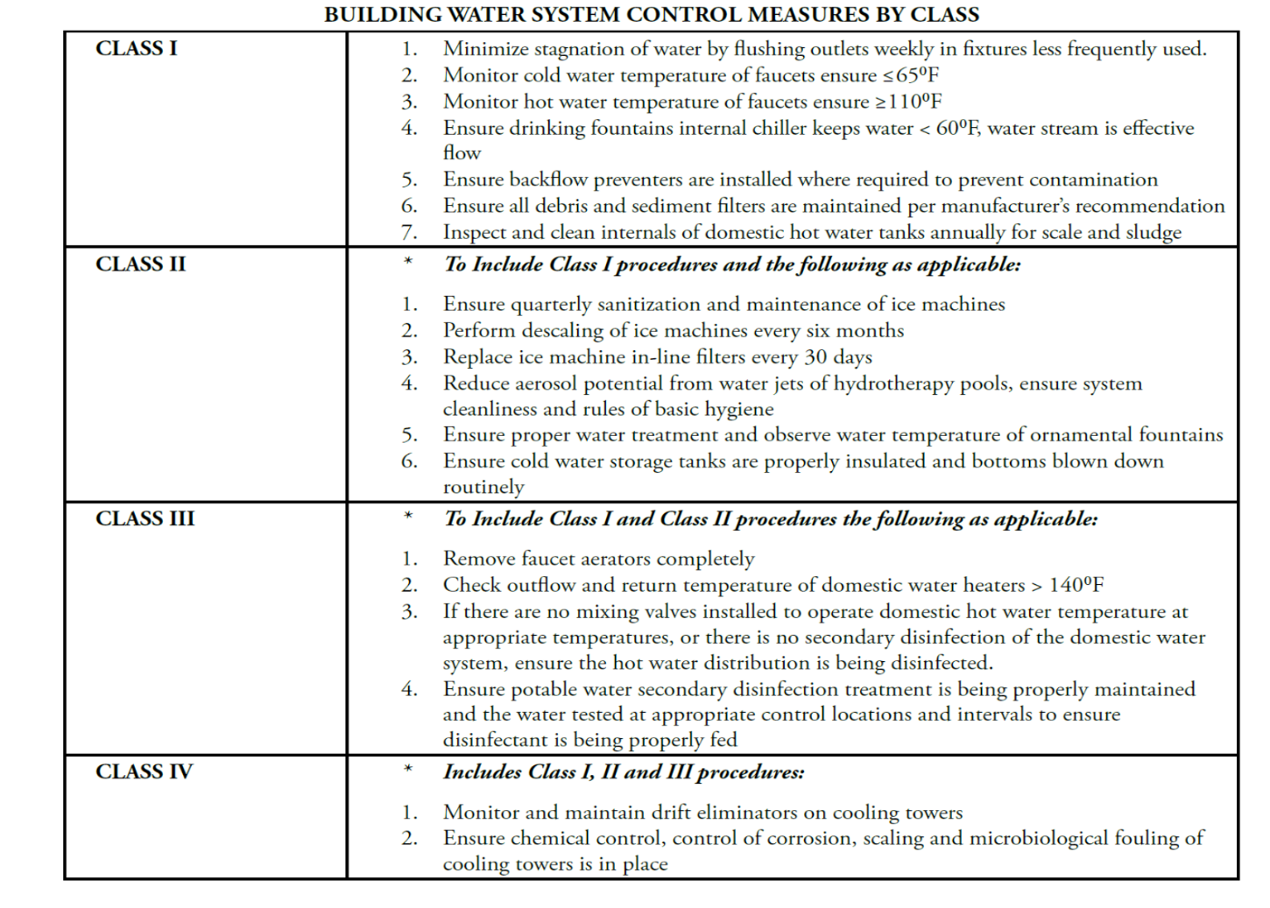
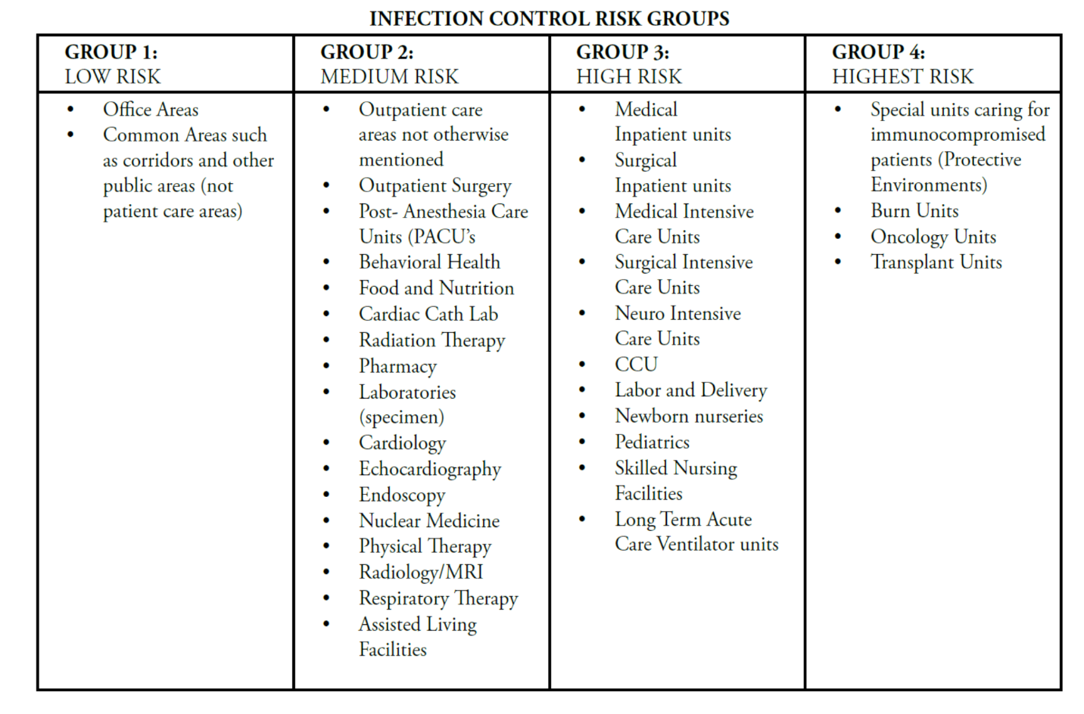
Appendix D: Team Roster

Team Member | Signature

Meeting Date: ____________________
Next Meeting: ____________________

Glossary of Terms:

Biofilm (slime): Germs and the slime they secrete that stick to and grow on any continually moist surface; provides housing, food, and security for many different types of germs, including Legionella.

Building water systems: Includes hot and cold-water distribution and all devices that use water people can be exposed to, such as hot tubs, decorative fountains, and cooling towers.

Control: To manage the conditions within your building according to your water management program.

Control measures: Things you do in your building water systems to limit growth and spread of Legionella, such as heating, adding disinfectant, or cleaning.

Control limits: The maximum value, minimum value, or range of values that are acceptable for the control measures that you are monitoring to reduce the risk for Legionella growth and spread.

Control points: Locations in the water systems where a control measure can be applied.

Contingency Response: Reaction to control measures that are persistently outside of control limits or events that pose an immediate risk to control of your building water systems; required for all instances when Legionnaires’ disease occurs but may also be appropriate for unexpected events such as equipment failure or acts of nature that disrupt the water system.

Corrective Action: Actions taken to reestablish control when monitoring or measurement values are outside control limits.

Dead Legs: Piping that is subject to low or no flow due to design or decreased water use such as capped pipes or unused faucets.

Disinfectant: Chemical or physical treatment used to kill germs, such as chlorine, monochloramine, chlorine dioxide, copper-silver ionization, ultraviolet light, or ozone.

Hazardous Conditions: Anything that, if not controlled, can contribute to the growth and spread of Legionella to a person.

Healthcare facility: A place where patients stay overnight for medical care or where people with chronic or acute medical problems* are treated; this may include inpatient or outpatient care areas.

Heterotrophic plate counts: A measure of the number and variety of bacteria that are common in water; a high count may indicate a high microbial load and the need for corrective action but cannot be substituted for Legionella testing.

Legionella: Bacteria that can cause Legionnaires’ disease.

Legionnaires’ disease: A serious type of pneumonia caused by Legionella.

Residual: The amount of disinfectant available in water to kill germs.

Scale and sediment: The mineral build-up in a water system that uses up disinfectant and supports germ growth and/or survival.

Stagnation: When water does not flow well; areas of stagnant water encourage biofilm growth and reduce temperature and level of disinfectant.

