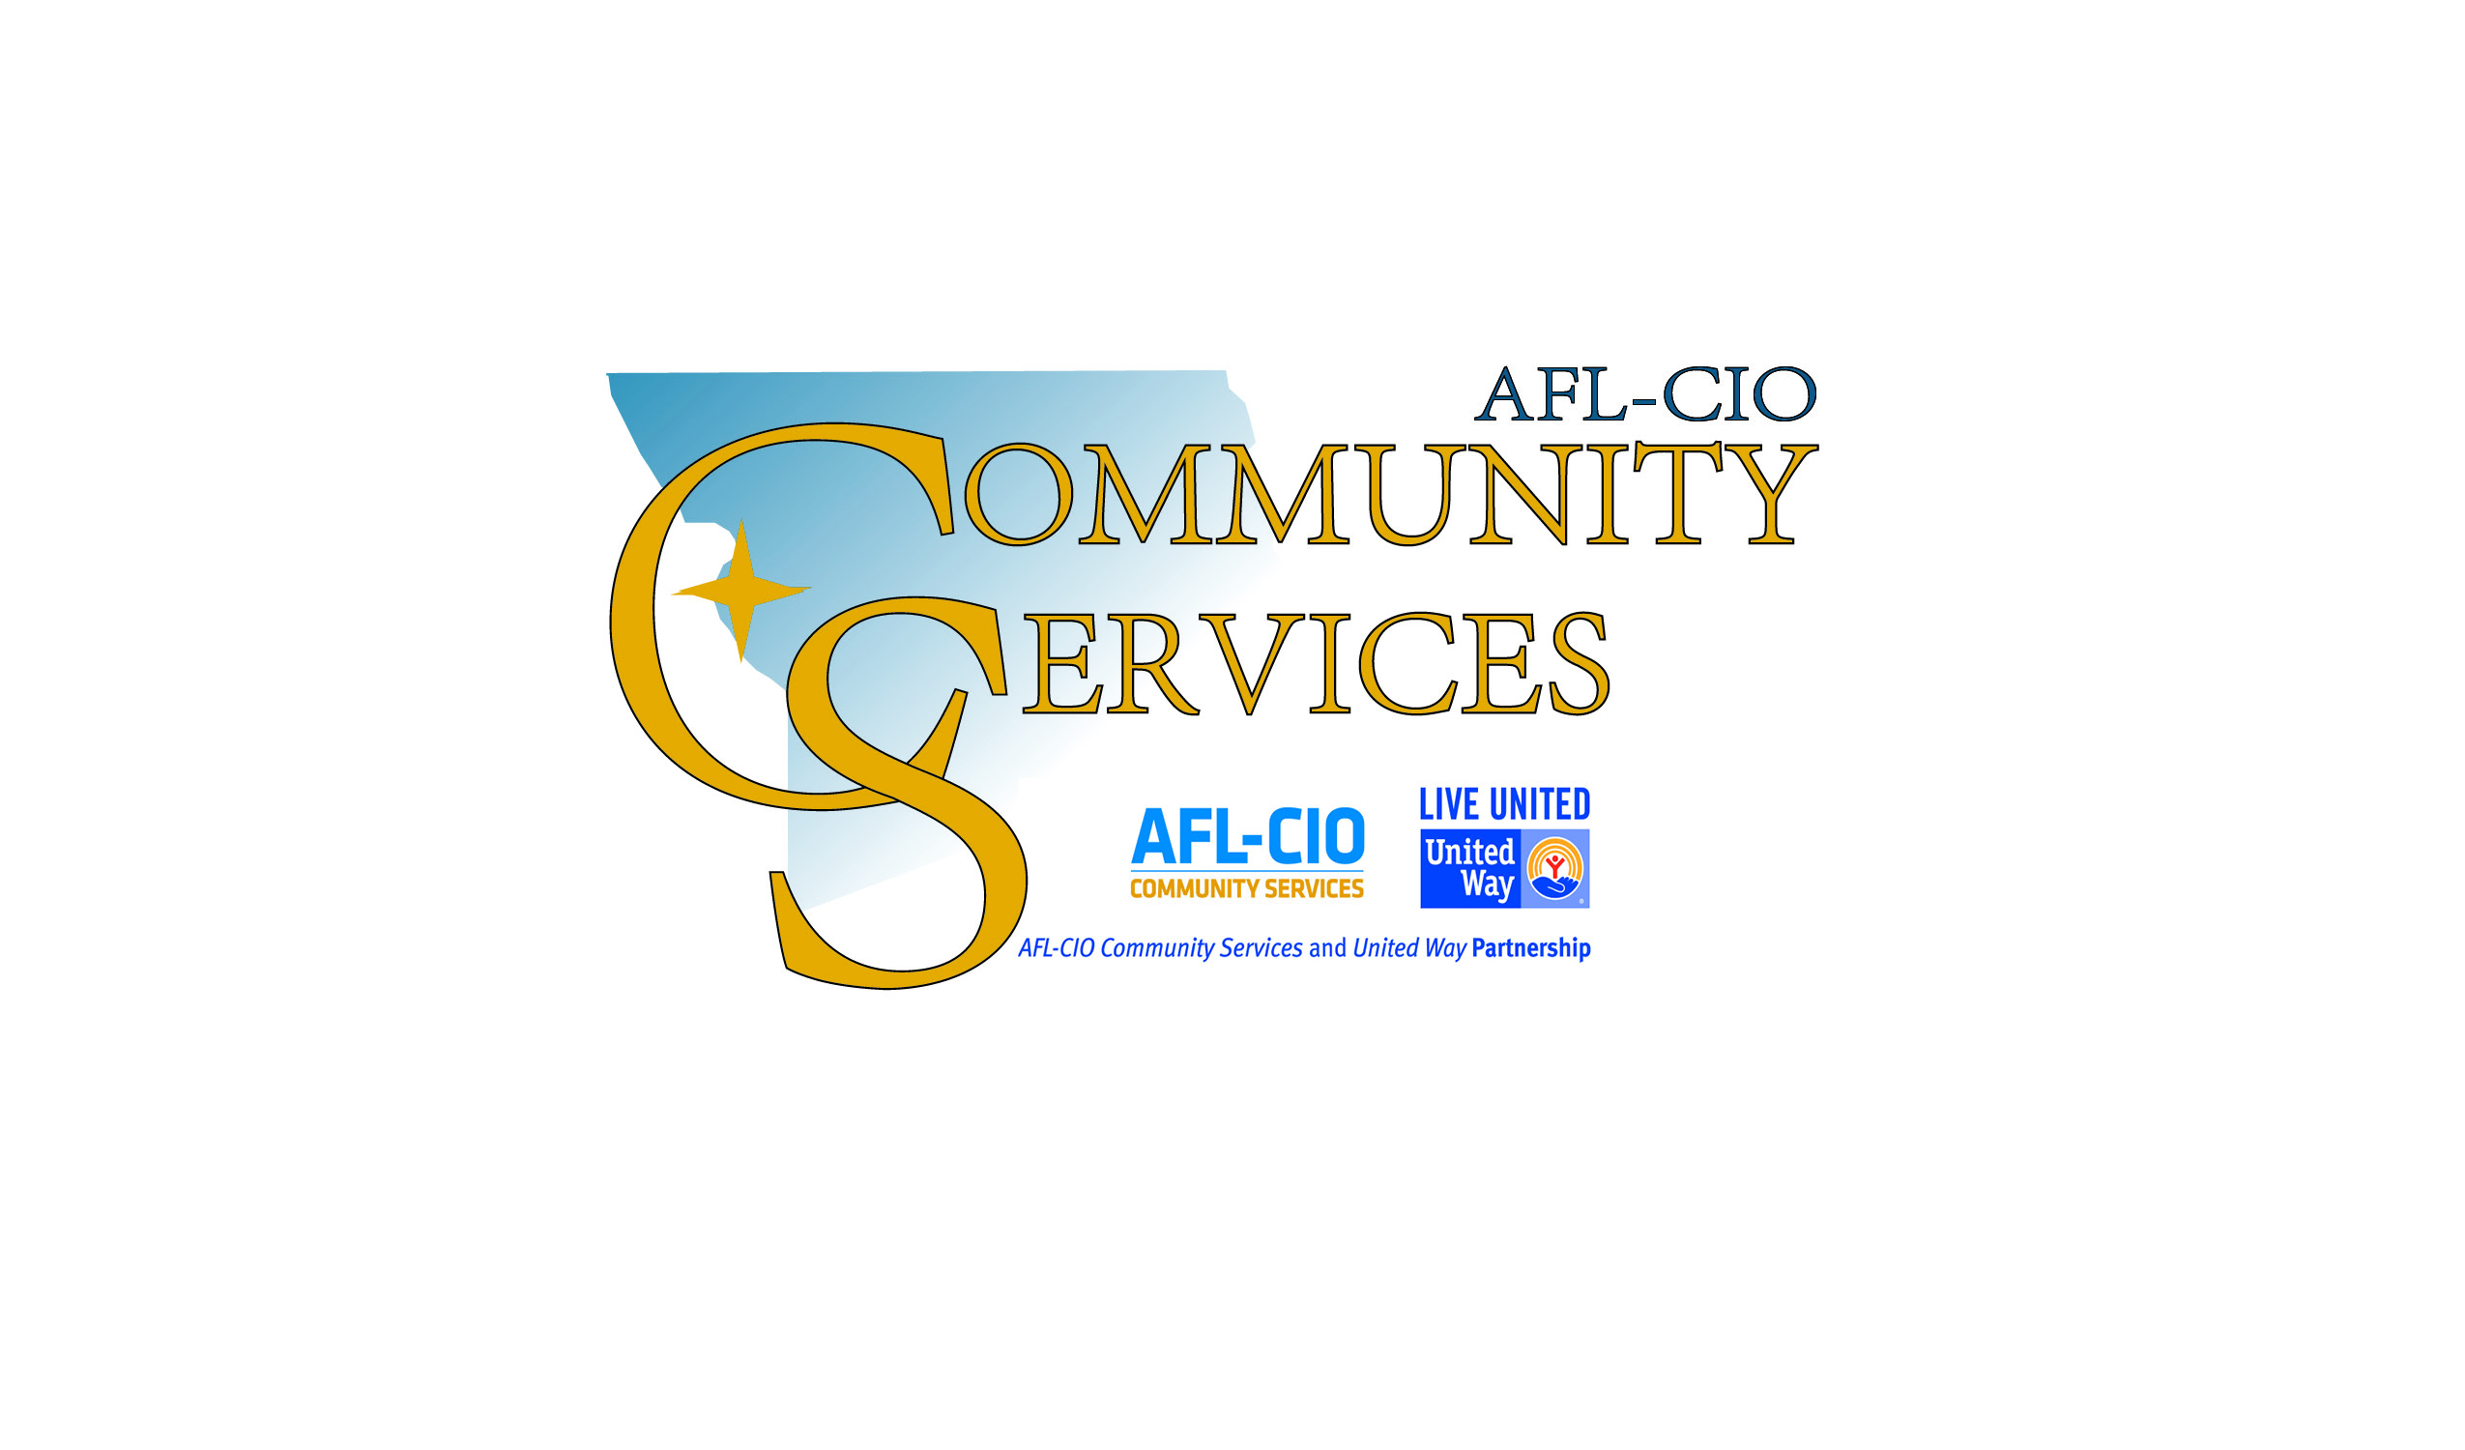

AFL-CIO Community Services Resource List

Please call ahead to confirm hours of service,
required documentation, and other important information.

For other information or referrals
dial 2-1-1 or 816.364.1131
to be connected to Help Me Hotline or visit
www.helpmenow.org
Updated: 10/29/2018

Abuse - Victims of Domestic and/or Sexual Violence
Child Abuse Hotline |  | 800.392.3738
Domestic Violence Services for Hearing Impaired |  | 800.380.3323
Elder Abuse Hotline |  | 800.392.0210
Legal Aid of Western Missouri | 706 Felix Street | 816.364.2325 or 800.892.2101
NW MO Children’s Advocacy Center | 1807 N Woodbine | 816.232.1744
Parental Stress Hotline |  | 800.367.2543
Rape Crisis Line |  | 816.232.1225
YWCA | 304 N 8th Street | 816.232.4481

Adult Education/Literacy
Missouri Career Center (GED Classes) | 2202 Frederick Avenue | 816.387.2380
University of Missouri Extension (Buchanan Cty) | 4125 Mitchell Avenue | 816.279.1691
Webster Learning Center ( GED, Free English classes, MO Option Program, Citizenship classes) | 1211 N 18th Street | 816.671.4020

Alcohol & Drug Abuse
Alcoholics Anonymous | 1207 Frederick Avenue | 816.364.2654
Alcoholics Anonymous | 404 S 8th Street | 816.279.5767
Family Guidance Substance Use Disorder Treatment | 901 Felix Street | 816.364.1862
Preferred Family Healthcare | 3510 Frederick Avenue | 816.364.6007
Substance Abuse Programs: AA, Ala-non | 401 S 11th Street | 816.364.9179

Childcare/Youth/Preschool/Education
Bartlett Center-Child Care Program | 409 S 18th Street | 816.364.6393
Bartlett Center-Latchkey Program | 409 S 18th Street | 816.233.8201
Big Brothers, Big Sisters of Greater St. Joseph | 1322 N 36th Street | 816.671.4090
Children First School Preschool Program | 304 N 8th Street | 816.232.0553
Community Action Partnership-Head Start | 817 Monterey Street | 816.233.8281
ESOL SJSD-enrollment for English learners K-12 | 1000 S 9th Street | 816.671.4119
InterServ Early Care and Education | 200 Cherokee Street | 816.238.4511
InterServ Early Care and Education | 5210 Mitchell Avenue | 816.279.6784
Missouri Child Care Assistance Program | 525 Jules Street | 816.387.2323
Noyes Home for Children | 801 N Noyes Boulevard | 816.232.5650
Parents As Teachers | 1208 S 28th Street | 816.671.4300
St. Joseph School District Administrative | 925 Felix Street | 816.671.4000
YWCA-Discovery Childcare | 304 N 8th Street | 816.232.4481
YWCA-Early Head Start | 304 N 8th Street | 816.232.4481
YMCA – Explorers Early Learning Center | 2302 Angelique Street | 816.387.8546
YMCA – Student Enrichment Program | 315 S 6th Street | 816.233.9622
YMCA – Y’s Kids World Early Learning Center – MWSU | 4525 Downs Drive | 816.271.4462
YMCA – Y-Stars Program (Individuals with Developmental Disabilities) | 315 S 6th Street | 816.233.9622
Youth Alliance - Educare, Youth Volunteer Corps, YAC Attack, Trips for Kids Cycling Program | 5223 Mitchell Avenue | 816.232.0050

Clothing
Birthright | 1018 N 19th Street | 816.279.8242
Fab-U-Less Finds | 1203 N 6th Street | 816.364.1131
Family Worship Center | 12293 County Road 438 | 816.244.0178  816.261.9197
Goodwill Store | 3615 Faraon Street | 816.232.0197
Grace House | 2638 Lafayette Street | 816.262.9401
Pivotal Point Thrift Store | 4826 Frederick | 816.259.5074
Jacob’s Closet for Children | 2623 Mitchell Avenue | 816.232.3374
Red Racks Thrift Store | 3025 S Belt Highway | 816.279.4900
Second Season Shop | 702 Messanie Street | 816.279.9136
Valley Community Center | 909 W Valley Street | 816.238.1709

Credit Counseling/Financial information
Apprisen (Div. of Consumer Credit Counseling Services) | 8826 Sante Fe Drive, Ste 110  Overland Park, KS 66212 | 800.355.2227
Family Support Division – TANF | 525 Jules Street | 816.387.2000
University of Missouri Extension (Family Financial Education Specialist) | 4125 Mitchell Avenue | 816.279.1691

Developmental Disabilities
Albany Regional Office | 525 Jules Street, Ste 210 | 816.387.2220
Bureau of Special Healthcare Needs | 207 E McElwaine, Cameron, MO | 800.451.0669
Missouri First Steps | 604 E Pawnee, Savannah, MO | 816.363.1078
Progressive Community Services | 1620 N Woodbine | 816.364.3827
United Cerebral Palsy | 3303 Frederick Avenue | 816.364.3836

Disabilities
Bridge Interpreting | 4420 S 40th Street | 816.244.0834
Family Support Division – Blind Services | 525 Jules Street | 816.387.2000
MERIL | 4420 S 40th Street | 816.279.8558

Emergency Shelter
Community Emergency Shelter at the Crossing | 701 S 8th Street | 816.617.2148
Noyes Home for Children | 801 N Noyes Boulevard | 816.232.5650
Salvation Army (families) | 618 S 6th Street | 816.279.2101
YWCA (women, mothers & children) | 304 N 8th Street | 816.232.4481 or 800.653.1477

Employment/Training
Alpha Staffing | 1123 S 10th Street | 816.364.0066
Experience Works | 2202 Frederick Avenue | 816.676.1161
Express Employment Professionals | 2620 N Belt Highway | 816.676.0303
GoodWORKS | 2202 Frederick Avenue | 816.232.3108
IMKO Staffing | 900 N Belt Highway | 816.233.4040
Kelly Services | 3715 Beck Road | 816.233.3411
Labor Max | 2019 S Belt Highway | 816.749.4562
Missouri Career Center | 2202 Frederick Avenue | 816.387.2380
Mo-Kan Regional Council\Dislocated Worker’s Program\Adult Program | 2202 Frederick Avenue | 816.387.2380
The Rehabilitation Institute | 701 Edmond | 816.390.8083
UCP | 3303 Frederick Avenue | 816.364.3836
Vocational Rehabilitation | 522 Jules Street | 816.387.2280
Youth Alliance, Youth Employment Program | 5223 Mitchell Avenue | 816.232.0050

Food
Family Support Division (SNAP) | 525 Jules Street, Room 127 | 816.387.2000
Family Worship Center Food Pantry | 12293 County Road 438 | 816.279.4635
InterServ - Food Pantry | 5400 King Hill Avenue | 816.238.4511 x 229
InterServ - Senior Meals Program | 5400 King Hill Avenue | 816.238.4511 x 235
InterServ Mobile Meals | 5400 King Hill Avenue | 816.238.4511 x 234
King Hill Baptist Food Pantry | 5708 King Hill Avenue | 816.238.1341
New Life Cathedral Food Pantry | 323 N 8th Street | 816.364.1093
Open Door Food Kitchen | 510 Edmond Street | 816.364.1085
Patee Park Baptist Food Pantry | 1107 S 10th Street | 816.233.6446
Second Harvest (Food pantry card & Fresh Start pantry) | 915 Douglas | 816.364.3663
Senior Meals Program, Bartlett Center | 409 S 18th Street | 816.233.8201
Senior Meals Program, InterServ  Wesley Senior Towers | 1000 Francis Street | 816.232.2839
St. Francis Xavier Church Food Pantry | 2701 Seneca (NE corner 27th & Seneca) | 816.671.9473
St James Church Food Pantry | 5815 Pryor Avenue | 816.238.0853
St Joseph Cathedral Food Pantry (diabetic food also available) | 519 N 10th Street | 816.232.7763
St. Mary’s Church Food Pantry | 1606 N 2nd Street | 816.279.1154
Valley Center Food Pantry | 909 W Valley Street | 816.238.1709
WIC-Women, Infants and Children | 904 S 10th Street | 816.271.4723

Housing/Rent Assistance
AFL-CIO Community Services (rental property list) | 1203 N 6th Street | 816.364.1131
Brittany Village | 1601 North 36th Street | 816.233.7626
Catholic Charities – Home Plus Program | 1123 S 10th Street | 816.232.2885
Community Housing Management | 730 S 6th Street | 816.233.4250
Habitat for Humanity | 3131 Frederick Ave | 816.279.2552
Pivotal Point Transitional Housing | 3000 Parkway A #7 | 816.689.1383
HOME Unit (Homeless) | 904 S 10th Street | 816.233.8536
InterServ | 5400 King Hill Avenue | 816.558.3152
MERIL (Independent Living) Community Access | 4420 S 40th Street | 816.279.8558
Northwood Terrace Apartments | 1203 Northwood | 816.232.3921
Oak Ridge Apartments | 1205 Angelique Street | 816.279.2784
Pleasant Heights Apartments | 2902 S 36th Place | 816.233.0383
St. Joseph Housing Authority | 2902 S 36th Street | 816.236.8200

Legal Assistance
Court Advocate Program, YWCA | 304 N 8th Street | 816.232.4481
InterServ Immigrant Services | 5400 King Hill Avenue | 816.238.4511 x 268
Legal Aid of Western Missouri | 706 Felix Street | 816.364.2325 or 800.892.2101
Public Administrator Personal Representative | 310 N 4th Street | 816.271.1442

Medical/Dental/Counseling/Support Groups
Angels Home Health | 4420 S 40th Street | 816.390.0900
The Center, Samaritan Counseling | 902 Edmond Street, Ste 203 | 816.364.4300
Community Health Line |  | 816.271.4000
Dept. of Health & Senior Services Special Health Care Needs (DHSS-SHCN) | 207 McElwain, Cameron, MO | 816.632.6008  800.451.0669
Family Guidance Center | 724 N 22nd Street | 816.364.1501
Family Support Division-Medicaid, MC+ | 525 Jules Street, Room 127 | 816.387.2000
Fresh Start (help for relationships & after breakup) | Location to be announced | 816.689.0120
Great Circle Intensive In-Home Services | 3500 N Village Drive | 816.205.1527
HOME Unit (Medical counseling homeless) | 904 S 10th Street | 816.233.8536
MERIL – (Sensory disabilities) registered nurse visits, consumer directed & in-home services | 4420 S 40th Street | 816.279.8558
Northwest Behavioral Health Services | 2303 Village Drive | 816.232.4417
Northwest Dental Services | 3608 Faraon Street | 816.364.6444
Northwest Health Services | 2303 Village Drive | 816.271.8261
Right Care |  | 816.271.8850
St Joseph PRC | 1502 N 36th Street, Ste A | 816.387.8090
Social Welfare Board Dental Clinic | 904 S 10th Street | 816.233-5189
Social Welfare Board Medical Clinic | 904 S 10th Street | 816.233.5188
Social Welfare Board Westside Clinic (GYM-Family) | 904 S 10th Street | 816.344.5233
WIC-Women, Infants and Children | 904 S 10th Street | 816.271.4723
Willowbrook Women’s Center | 1502 N 36th Street Ste A | 816.244.7824
YWCA, Encore Plus Program  Referrals for FREE mammograms | 304 N 8th Street | 816.232.4481 (English)  816.273.6665 (Spanish)

Mental Illness
Family Guidance Center | 724 N 22nd Street | 816.364.1501
Mental Health Crisis Line |  | 888.279.8188
Mosaic Life Care | 5325 Faraon | 816.271.7273
Northwest Behavioral Health Services | 2303 Village Drive | 816.232.6818
The Center (counseling) | 902 Edmond Street, Ste 203 | 816.364.4300

Seniors
Community Housing Management | 730 S 6th Street | 816.233.4250
Division of Senior Services | 525 Jules Street | 816.387.2100
Experience Works (Senior employment) | 2202 Frederick Avenue | 816.676.1161
Faith in Action | 528 N 8th Street | 816.271.7279
InterServ | 5400 King Hill Avenue | 816.232.8080
MERIL | 4420 S 40th Street | 816.279.8558
NWMO Area Agency on Aging – Albany, MO | 504 US Highway 136, PO Box 265, Albany, MO | 660.726.3800  888.844.5626
NWMO Area Agency on Aging-St. Joseph  Aging, Disability Resource Consultant | 528 N 8th Street | 660.726.3800  816.232.3393

Transportation/MO Driver License/State ID
Jefferson Bus Lines | 702 S 5th Street | 816.233-6700
MO License/State ID Office | 1301 Village Drive | 816.232.1455
St Joseph Transit | 702 S 5th Street | 816.233.6700

Utilities
AFL-CIO Community Services | 1203 N 6th Street | 816.364.1131
Catholic Charities | 1123 S 10th Street | 816.232.2885
Community Action Partnership | 817 Monterey Street | 816.233.8281
InterServ | 5400 King Hill Avenue | 816.558.3152

Veterans
American Red Cross (retirees only) | 401 N 12th Street | 816.232.8439
Catholic Charities | 1123 S 10th Street | 816.232.2885
Second Harvest Community Food Bank  Military Friendly Policy-Food Assistance | 915 Douglas | 816.364.3663
VA Veterans Outpatient Clinic | 3302 S Belt Highway, Ste. P | 1.800.952.8387  Ext: 56925
Veteran’s Employment Services | 2202 Frederick Avenue | 816.387.2380
Veteran’s Service Officer | 525 Jules Street | 816.387.2841
Women’s Veteran Coordinator | 525 Jules Street | 816.387.2841

Miscellaneous
Adopt-A-Family Christmas Program | 1203 N 6th Street | 816.364.1131
Catholic Charities Services to Young Families | 1123 S 10th Street | 816.232.2885
Foster Parenting, Family Support Division | 525 Jules Street | 816.387.2000
InterServ, Non English Speaking Services | 5400 King Hill Avenue | 816.238.4511 x 268
JUMP, program for teen mothers | 304 N 8th Street | 816.232.4481
MERIL – Bridge Interpreting Services | 4420 S 40th Street | 816.244.0834
MERIL – Telecommunication Access Program (TAP) | 4420 S 40th Street | 816.279.8558
Mom’s Time is for mothers of children 6 weeks to preschool. YWCA | 304 N 8th Street | 816.232.4481
Mourning Star (Grief Support Group) | 3110 Cook Road | 816.279.3621
The Crossing | 629 S 8th Street | 816.273.0095  816.617.2148

AFL-CIO Community Services follows the standard practices established by the Alliance of Information and Referral Systems (AIRS) for inclusion/exclusion criteria. Criteria determine the organizations that will be included in or excluded from the resource database.

The agency/service provider may be either government or non-profit 501-(C). For-profit organizations and unincorporated groups meeting critical human service needs, which are not covered by a governmental or non-profit organization, may also be included following review.

Disclaimer:
Special conditions may apply for agencies and or programs that serve vulnerable populations, programs will be reviewed for inclusion. Inclusion of a program/service does not in any way represent or imply a determination or approval of the quality of those services; nor does it imply endorsement by AFL-CIO Community Services. Exclusion does not reflect on any organization’s contribution to the community.

Please call ahead to confirm hours of service,
required documentation, and other important information.

For other information or referrals
dial 2-1-1 or 816.364.1131
to be connected to Help Me Hotline or visit
www.helpmenow.org

