**Long Term Services and Supports (LTSS) Subcommittee Meeting Agenda**

June 27, 2024

1. Review of prior discussion on “re-bucketing” the focus areas of the subcommittee based on gaps identified in the town hall summary
2. Current Recommendations: Provided a summary of the more detailed recommendations
   1. In-home
      1. Feasibility study on innovative HCBS models of care (i.e. new ways to do business and serve people)
      2. Study and implement plans to bolster staffing retention (i.e. invest in HCBS staff)
      3. System/procedural changes to current HCBS program (i.e. increase efficiency)
      4. Online platform/hub to improve access (i.e. navigation/efficiencies)
      5. Explore assistive technology (i.e. add service to existing HCBS model)
      6. Explore in-home therapies (i.e. add service to existing HCBS model)
      7. Identify & monitor LOC caps/concerns (i.e. access to existing HCBS model)
   2. LTC Institutions
      1. Increase staffing (i.e. invest in LTC staff)
      2. Increase funding for surveyors, facility staff, & ombudsman (i.e. invest in existing LTC model)
      3. Increase MH services for LTC residents & facilities (i.e. new care options for persons with SMI)
   3. Navigation
      1. Develop NWD System via “hubs” (i.e. improve access, increase efficiency, education/training for all about existing LTSS system)
      2. Integration of medical/social/LTSS care via technology (i.e. improve access, increase efficiency)
3. Discussion about continuum of physical space & service array concepts
   1. 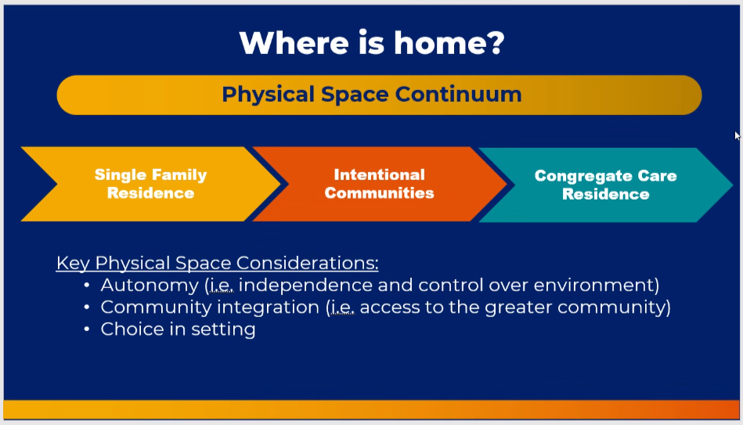Breaking down and think about existing options differently. Physical space continuum is not an either or situation. Intentional communities include things like retirement communities or other neighborhoods with assistance or residential care facility or assisted living. Last time we talked about needed to add more mid level options in the intentional community space. Relationship based supports (PACE programs, foster grandparent programs.
   2. 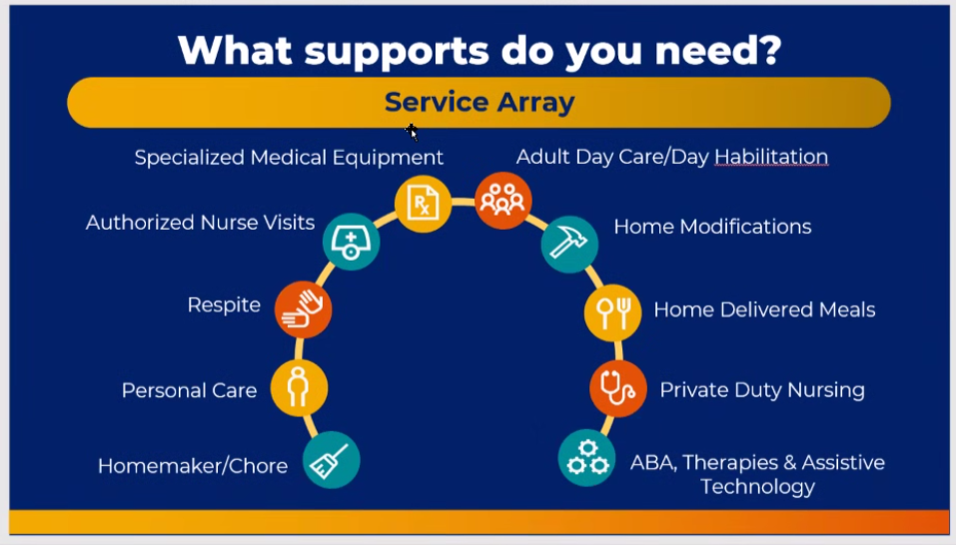 What needs do you have related to chronic conditions. Where do you want to see your dentist or physician.
   3. 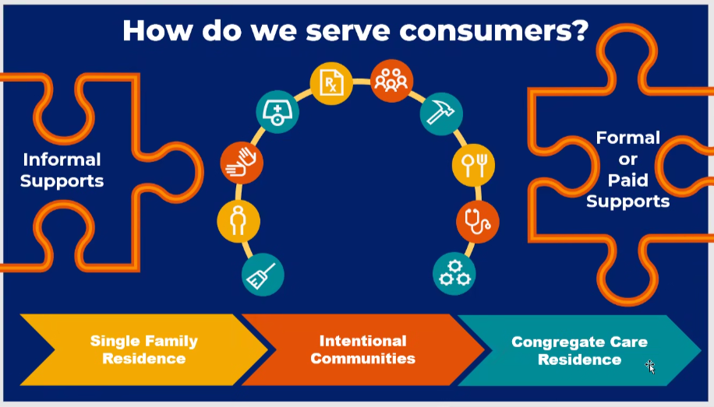 This all comes together to be how we serve consumers. Including formal and informal supports. Think about this continuum as we re-bucket LTSS to include all areas.
   4. 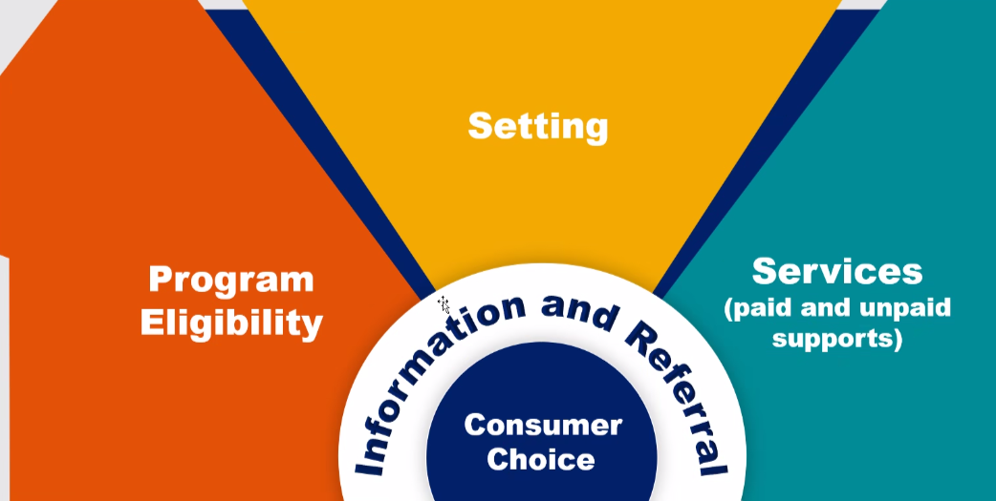
   5. Vickie Riddle: This plan would create an incredible expansion of funding to provide the services. Are we responsible for determining the funding as well? Melanie: This would be a possible expansion; there are areas of the state that have some of the mid-range options. This would be more about robust access. We talked about host-homes and other options that currently exist in some way. Not all of these would be government supported. Some, if not most of this, would come from the private sector. This would include things like retirement communities. Yes, it will cost money. This plan will help us decide where to put our money.
   6. Jessica Rooks (Elder Law): Currently there are some big gaps that hinder people from using the current Medicaid HCBS system. Even just getting the current system working better would be helpful. Melanie: Our mission in this subcommittee and MPA is to look at the current state of the system (bolster access to what we currently have) and looking 10 years out and what gaps we can fill. We can use this plan to think and plan big. We need better navigation for the current systems. A part of navigation is not just on the formal/paid supports. It’s also about looking at the broader needs and finding local organizations to help as well.
4. Re-bucketing options (accept the overlap!): Looking at short-term and long-term plans. These buckets are based on the town hall feedback and would span the entire continuum of care (LTCF, in-home, etc.)
   1. LTSS Workforce Recruitment & Retention
   2. Education & Training of the LTSS workforce and the general public and healthcare workers and anyone related to referrals into the system. This can be a function of better retention
   3. Expand continuum of care and service array Developing more mid-range options. Living in the community with support and maybe not in a single-family residence
   4. Advanced planning for LTSS starting at a younger age to determine what you want as you age. Financial planning education in schools about retirement, etc.
   5. Affordability for consumers Tax incentives, insurance, what is needed to make LTSS more affordable over time
   6. Respect and dignity of consumers Quality of care, person centered, choice
   7. Navigation Need to know where to go to get needed services, peer models, NWD hubs, better ease of access to technology
   8. Vickie Riddle: Major concern is that there is no available, affordable housing for anyone, especially accessible housing for seniors. Melanie: We are one of seven subcommittees. We have one subcommittee dedicated specifically to housing. Vickie: I served on that subcommittee too, but I don’t see that here. Melanie: We are each equal subcommittees set to tackle different issues. We know that this isn’t a vacuum and is only one of seven core areas of aging with dignity.
   9. Marjorie Moore: I think it makes sense to tackle these as a large group, instead of as individual workgroups.
   10. Jordanna: possibly break out initially to get some starting ideas before discussing in a large group.
5. Reminder about the needs assessment survey and timing

Bob Pieper: Dona Rodriguez is heading a group to coordinate education and NWD information. Do we have anyone who is skilled in service mapping? Might be a good idea to start actively surveying what services are available and where the gaps are. Vickie: She is working with MARC in KC to get the best maps they have of services available and service deserts. They are working on it. MARC may be able to provide additional services across the state. Melanie: there are ten AAAs across the state. Aging Ahead may be able to help in the St. Louis area. Make sure we’re being cognizant of what services would be included. Who is the partner in NWD? Melanie: Missouri received a governance grant that is being led by UMKC IHD – Shelly, Beth, and Angelina.

Move meeting to second Thursday of the month at 3 pm to avoid upcoming conflicts.