August 13, 2013

MEMORANDUM FOR PARTICIPATING REASSESMENT PROVIDERS

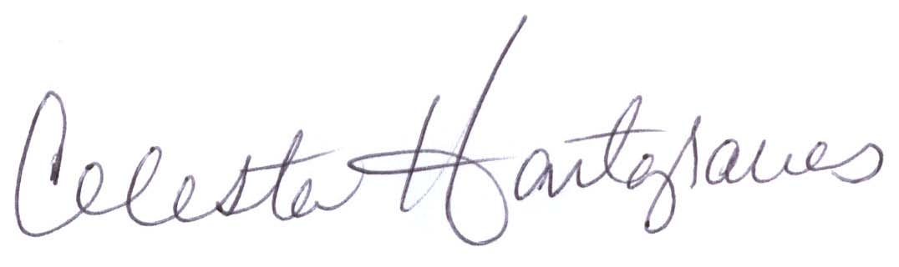
FROM: Celesta Hartgraves, Director
Division of Senior and Disability Services

SUBJECT: Clarification of HCBS Web Tool Reassessment Data Entry

Entry of any reassessment data for the InterRAI HC and associated care planning into the HCBS Web Tool must be completed by a qualified/trained assessor. Individuals approved to do the data entry are limited to the assessor who completed the InterRAI HC and developed the care plan in the participant’s home or another qualified/trained assessor entering the information on their behalf. Administrative or clerical staff or any other staff member who is not qualified/trained to complete reassessments and enter them into the HCBS Web Tool are not permitted to do the data entry.

Section T of the InterRAI HC must contain the name of the assessor who completed the InterRAI HC and developed the care plan as well as identify the provider agency (see example below). When the information is entered by a qualified individual other than the assessor on their behalf, the name of the assessor who did the home visit must be documented as well as the name of the individual completing the data entry.

Example of signature line when data entry done on behalf of an assessor:

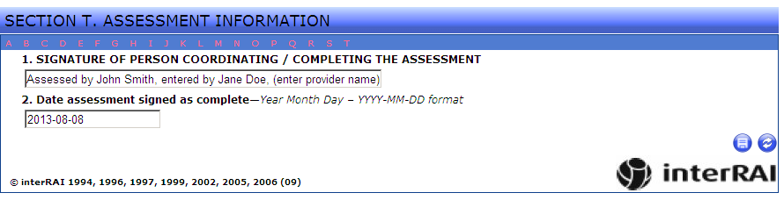

Any questions regarding this memorandum should be directed to the Bureau of Program Integrity via e-mail at programintegrity@health.mo.gov or by phone at 573-526-8557.

