Name: | DOB: | DCN:
Observations and Findings:

Indicate on body diagram any skin tears, abrasions, bruises, scars, etc.

Back Left Front Right
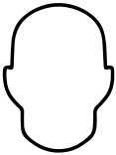
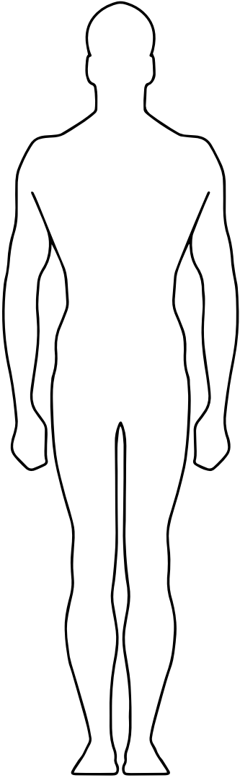

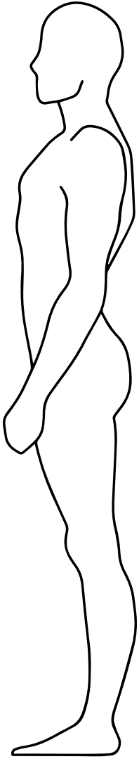
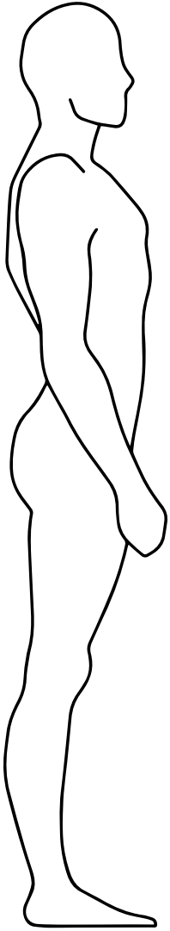

L R R L
Nurse Signature: ______________________________________________ Date: ___________________

