Medicaid Status Information

Fusion Quick Guide

Table of Contents
Participant Banner Medicaid Indicators 2
MMIS Info Tab 3
Determining when the spenddown was met 3
How to identify a participant’s locked in Managed Care Group? 4

Participant Banner Medicaid Indicators
Medicaid indicators are located on each Participant’s Banner in Fusion.
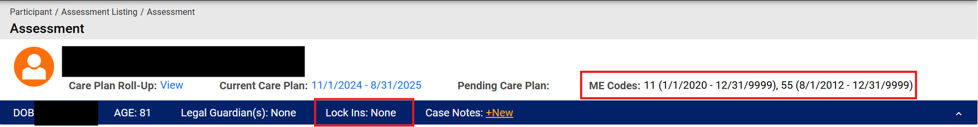
All Active ME Codes will display in the Participant Banner as shown in the large red rectangle above. Please refer to 2.00 Appendix 3 for Medicaid Eligibility code description and available services.
  - ‘ME Codes: None’: This indicates the participant does not currently have Medicaid.
  - ‘ME Codes: 11 (1/01/2020 -12/31/9999): This indicates the ME code and the dates the participant is active with that code. (“9999” indicates there is no end date).
  - ‘Lock Ins’ information (small red rectangle above): Displays information regarding Spenddown Met or not met for the current month, Managed Care Lock Ins, and Ticket to Work.
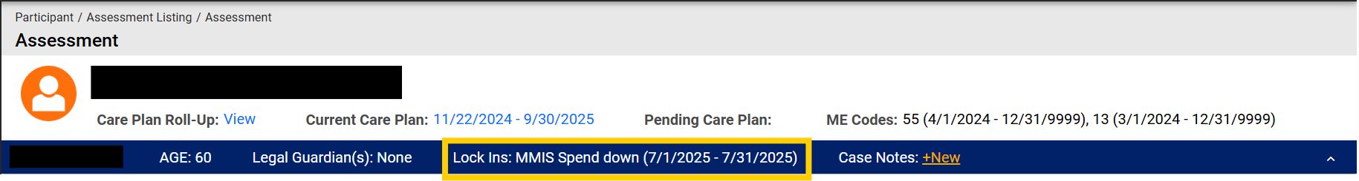

  - ‘Lock ins: MMIS Spend down (current month’s date)’
- Indicates Spenddown was met for current month
  - ‘Lock ins: MMIS Ticket to Work (current month’s date)’
- Indicates Premium met for current month
  - ‘Lock Ins: None’
- Indicates no spenddown or spenddown not met

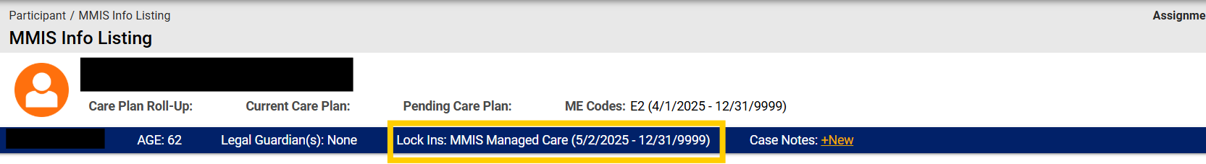
  - ‘Lock ins: MMIS Managed Care (dates currently locked in)’:
- The end date for all active Medicaid Services is set to ‘12/31/9999’. This indicates there is currently no expiration date.

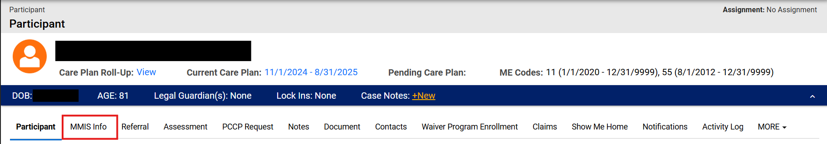
MMIS Info Tab
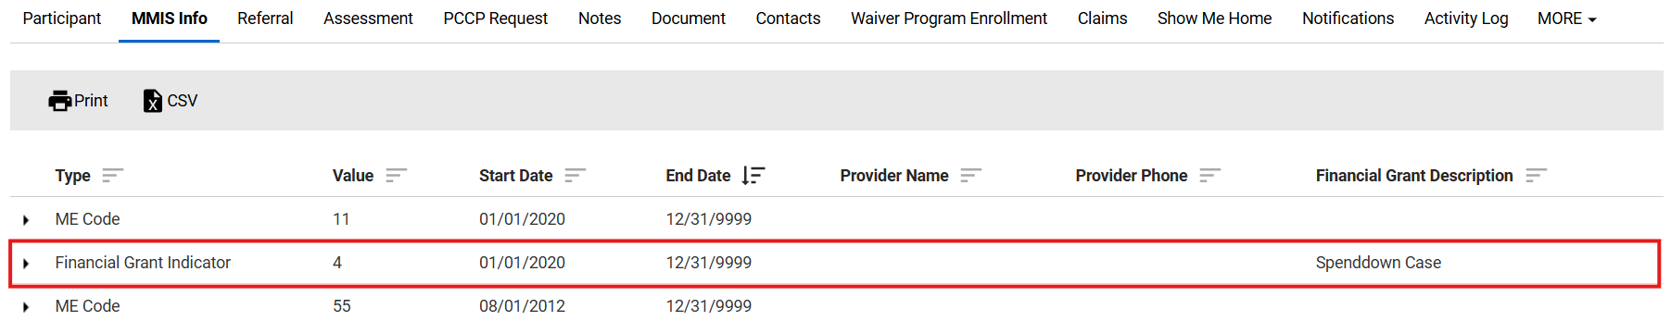
Additional spenddown information can be found on the ‘MMIS Info’ tab
  - The ‘Financial Grant Indicators’ row will display ‘Spenddown Case' or 'Non-Grant Case” in the ‘Financial Grant Descriptions’ column.
- ‘Spenddown Case’: Indicates participant has a spenddown
- ‘Non-Grant Case’: Indicates participant does not have a spenddown.

Determining when the spenddown was met?
  - "MMIS Spend Down” shows the month by month spend down history
  - The "start" and "end date" columns list the months for which the spend-down was met.
- Note any missing months, as this signifies the participant did not meet their spend-down requirement for that time.
- Example: As shown below, there was a gap in met spend-downs between October 2024 and January 2025. It was met once in February 2025 and not afterward.
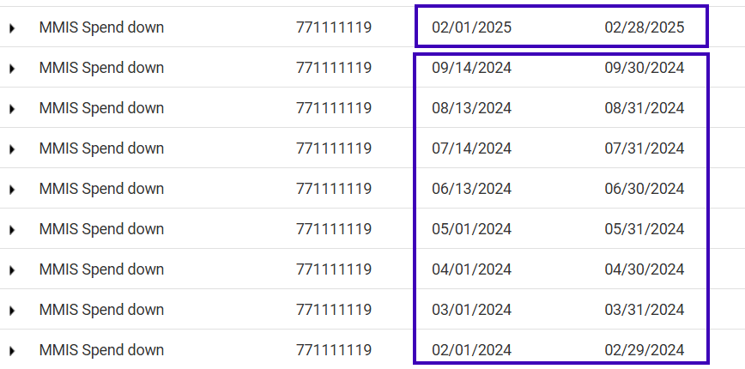

How to identify a participant’s locked in Managed Care Group?
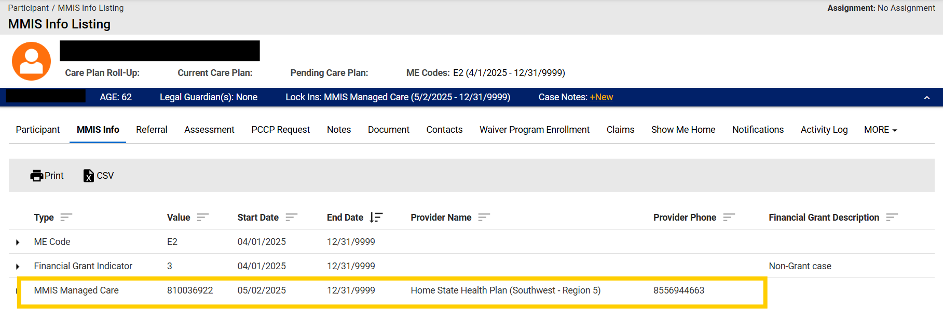
The Managed Care Provider Name and Phone Number will be displayed as “MMIS Managed Care”.

