**How to Enable IE Mode in Microsoft Edge**

1. Open Microsoft Edge.

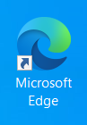

1. Click the ellipsis button (…) in the top-right corner.



1. Select “Settings.”

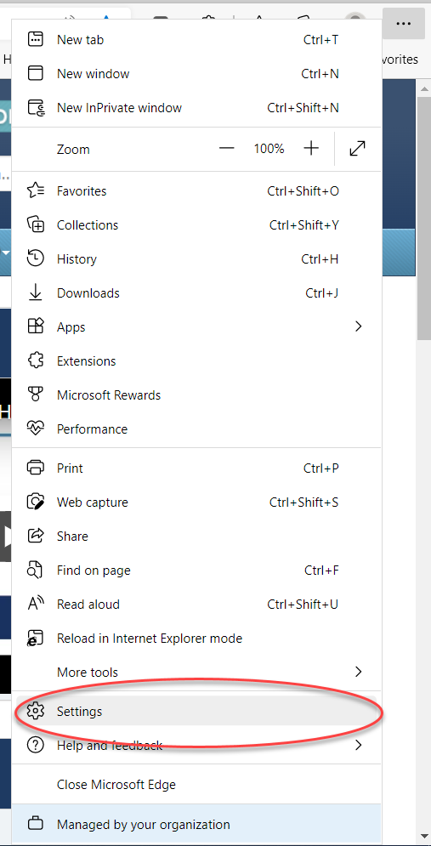

1. Click on “Default Browser.”

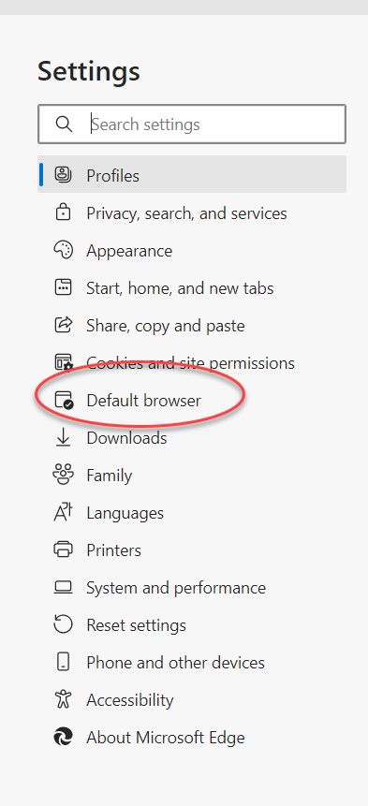

1. Under the “Let Internet Explorer open sites in Microsoft Edge” section, click the dropdown menu and select “Incompatible sites only (Recommended).”

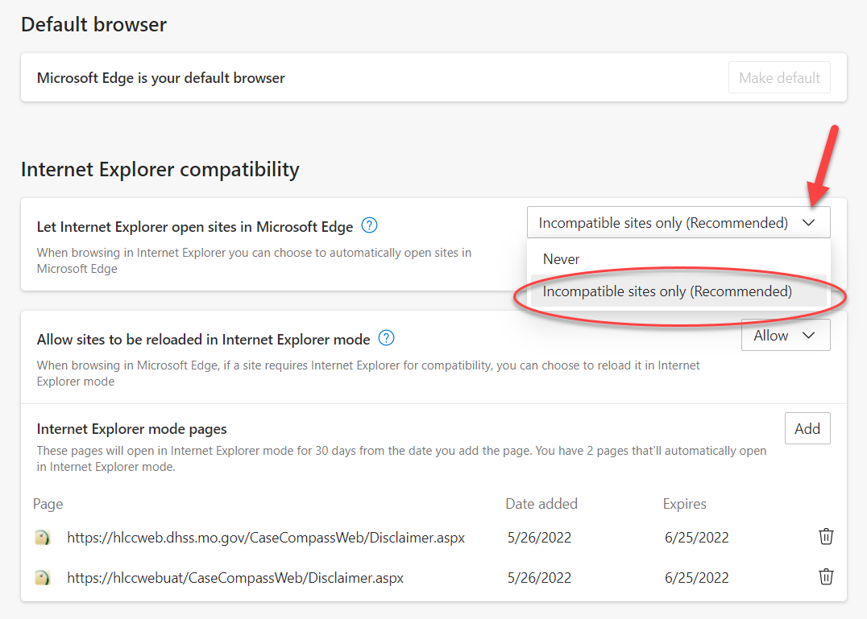

1. Under the “Allow sites to be reloaded in Internet Explorer mode” section, click the dropdown menu and select “Allow.”

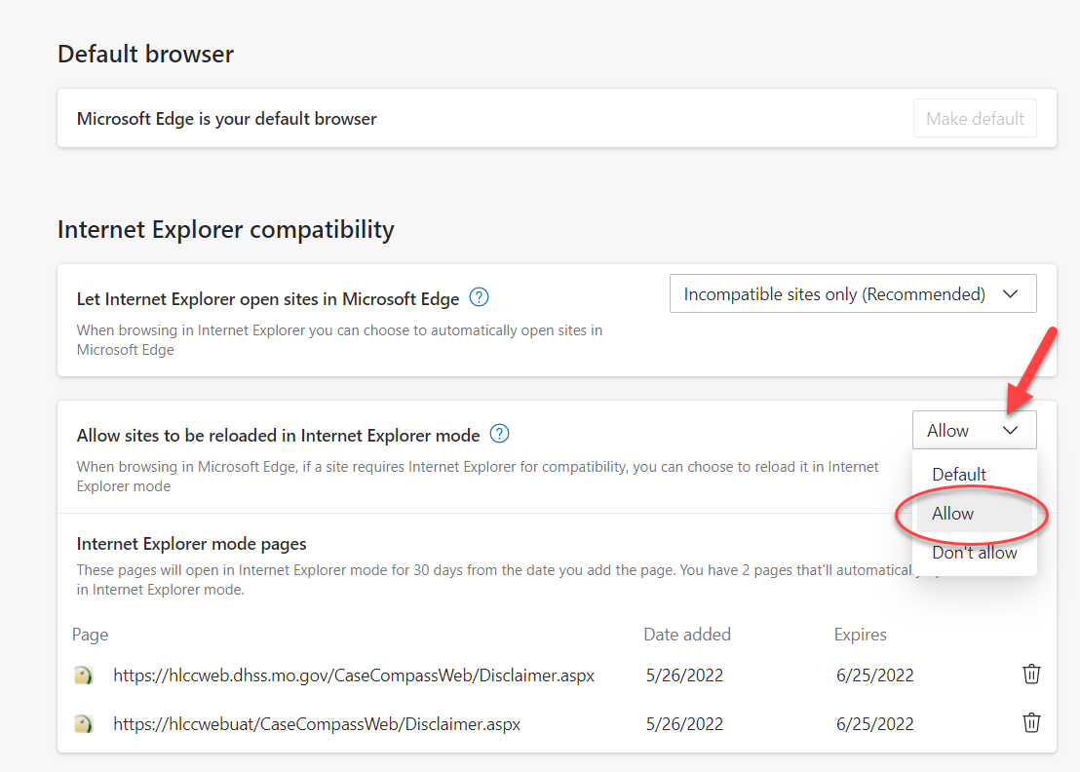

1. Click “Restart.” If Edge does not automatically reopen after clicking restart, manually reopen Edge.

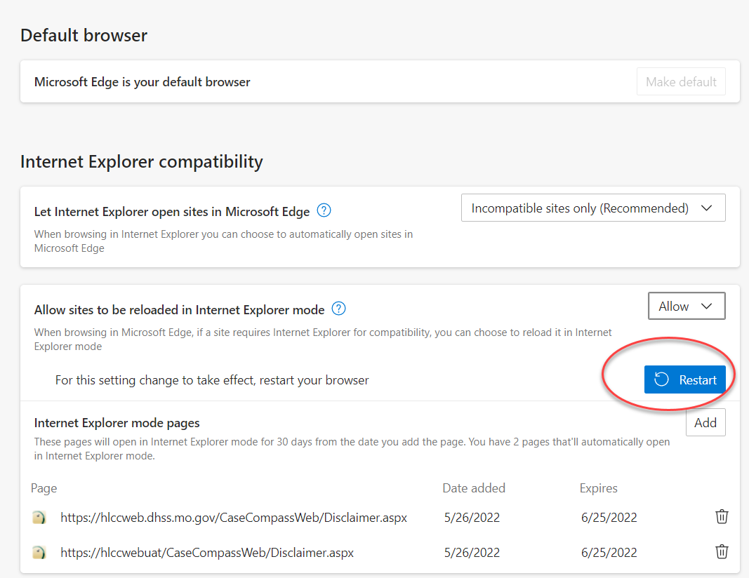

1. Once Edge has been restarted, navigate to the Case Compass website and login.

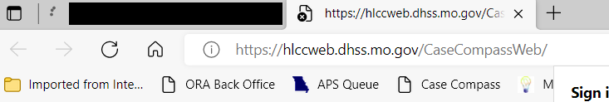

1. Once logged in to Case Compass, click the ellipsis button (…) on the top-right corner.
2. Select “Reload in Internet Explorer mode,” and if prompted, log into and/or reload Case Compass.

*Note if “Reload in Internet Explorer mode” cannot be selected. Skip to #12.

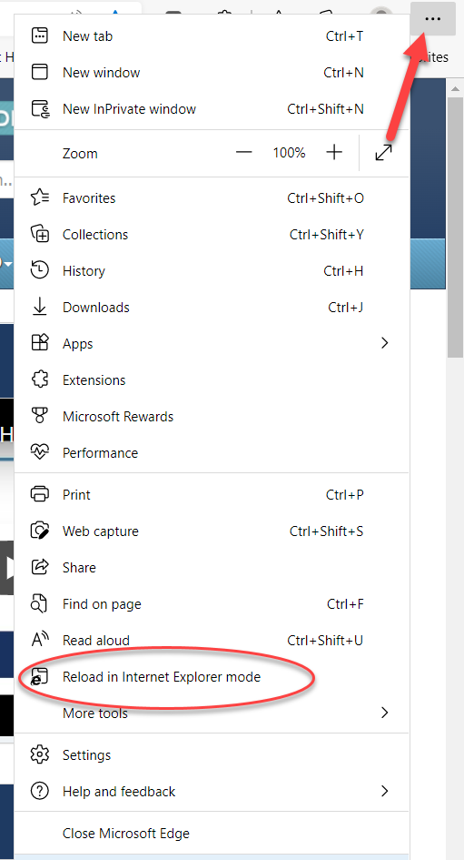

1. Once page has reloaded, the below pop-up should appear. Ensure that the “Open this page in Internet Explorer mode next time” toggle is set to on. Click done.

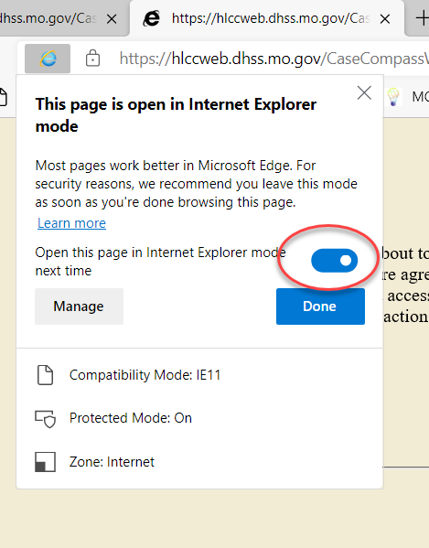

1. Case Compass can be saved as a favorite in Edge by clicking the star symbol on the address bar. Enter a name for the favorite, and select the folder you wish to save your favorite in. Click “Done.”

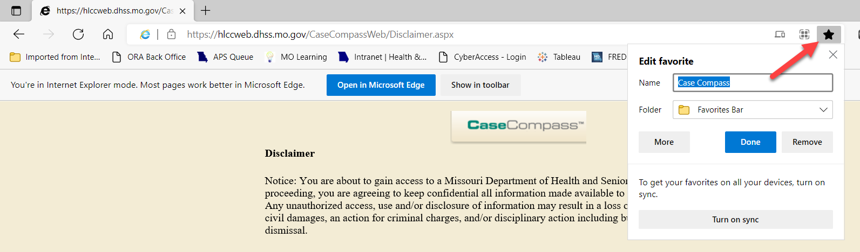

**Note**: If set up properly, you should NOT have to follow these directions each day. After set up, Case Compass should open in Internet Explorer mode each time it is accessed from Edge.

**Three ways to verify that you are using Compatibility mode**:

1. When active in Case Compass using Edge, the IE ‘e’ appears in the address bar.

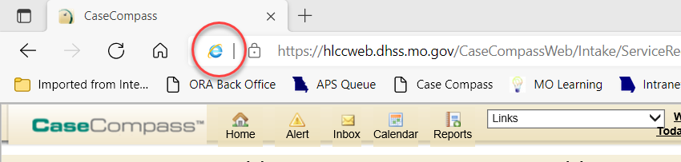

1. In the address bar, you will see a message stating “You’re in Internet Explorer mode.” If you would like to close this message bar, click the ‘x’ on the right side of the message bar. Do NOT click “Open in Microsoft Edge.”

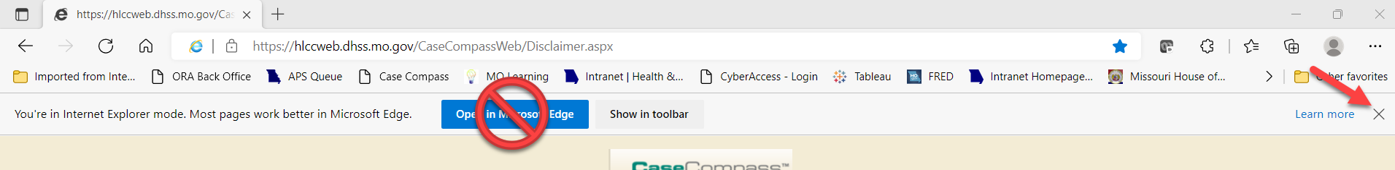

1. Click the ellipsis button (…) on the top-right corner. When viewing the menu, you should see an option that says “Exit Internet Explorer mode.” Do NOT click the button, this will simply verify that you are working in the correct mode.

