APS 20-05

January 29, 2020

**MEMORANDUM FOR DIVISION OF SENIOR & DISABILITY SERVICES**

**ADULT PROTECTIVE SERVICES STAFF**

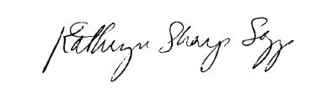

From: Kathryn Sharp Sapp, Bureau Chief

Division of Senior and Disability Services

Bureau of Policy & Staff Development

Subject: Philosophy

The Adult Protective Service (APS) Policy Manual has been updated. Policy 1701.10: Philosophy contains an enhanced APS mission statement that is is as follows: “To protect & support vulnerable Missourians impacted by abuse, neglect, &/or exploitation.”

**NECESSARY ACTION:**

1. Review this memorandum with all APS staff.
2. Review new chapter 1701.10: Philosophy
3. All questions should be cleared through normal supervisory channels and directed to: Amanda Veltrop at [APSPolicy@health.mo.gov](mailto:APSPolicy@health.mo.gov) or by calling 573-526-5391.

**APS Manual Revisions:**

1. APS Policy 1701.10: Philosophy -- Updated