APS 20-04

January 29, 2020

**MEMORANDUM FOR DIVISION OF SENIOR & DISABILITY SERVICES**

**ADULT PROTECTIVE SERVICES STAFF**

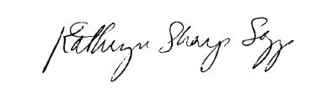

From: Kathryn Sharp Sapp, Bureau Chief

Division of Senior and Disability Services

Bureau of Policy & Staff Development

Subject: Fraud Resource

A Fraud Resource Letter has been added to the Forms Section of the Adult Protective Services (APS) manual. This resource letter should be given to eligible adults when there are concerns that they have been the victim of a scam. When DSDS receives a report involving a scam, the APCW should gather as much information from the reporter to determine if additional issues are affecting the life and financial status of the reported adult.

**NECESSARY ACTION:**

1. Review this memorandum with all APS staff.
2. Review the Fraud Resource Letter
3. All questions should be cleared through normal supervisory channels and directed to: Michelle Humphrey at [APSPolicy@health.mo.gov](mailto:APSPolicy@health.mo.gov) or by calling 573-526-8502.