APS 20-02

August 29, 2019

MEMORANDUM FOR DIVISION OF SENIOR & DISABILITY SERVICES ADULT PROTECTIVE SERVICES STAFF

From: Kathryn Sharp Sapp, Bureau Chief 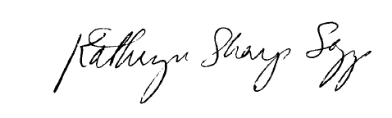
Division of Senior and Disability Services
Adult Protective Services Policy & Staff Development Unit

Subject: Fillable Mandated Reporter Form

The fillable version of the Mandated Reporter Form is now available for use on the DHSS internet site on the following pages:

https://health.mo.gov/seniors/
https://health.mo.gov/seniors/abuse.php
https://health.mo.gov/safety/abuse/

Mandated reporters may now utilize the fillable feature and then fax the report to CRU at
573-751-4386. DSDS staff may now direct mandated reporters to the form for non-emergency concerns, especially when CRU is experiencing high call volumes.

The department is exploring an option to be able to email the fillable form to CRU. When that option becomes available, another memo will be sent out to alert staff.

NECESSARY ACTION:
- Review this memorandum with all staff.
- All questions should be cleared through normal supervisory channels and directed to: Amanda Veltrop at APSPolicy@health.mo.gov or by calling 573-526-5391.

KSS/av

