APS-19-01

April 9, 2019

**MEMORANDUM FOR DIVISION OF SENIOR & DISABILITY SERVICES**

**ADULT PROTECTIVE SERVICES STAFF**

From: Kathryn Sharp Sapp, Bureau Chief 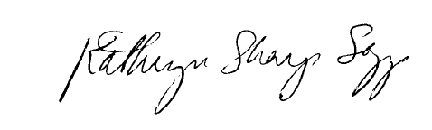

Division of Senior and Disability Services

Adult Protective Services Policy & Staff Development Unit

Subject: Worker Safety Policy Enhancement

As a result of the recent Situation Management & Response Techniques (SMART) training provided by the Adult Protective Services Policy & Staff Development Unit, the APS Policy 1705.05: Worker Safety policy has been updated to reference the use of the SMART training, as well as how to request future training participation.

The trainers are working closely with the Regional Managers to accommodate scheduling of additional and on-going trainings. As mentioned in the recent Director’s Update, our trainers are constantly looking for new topics or ways they can help staff learn and grow, therefore please email suggestions to [APSPolicy@health.mo.gov](mailto:APSPolicy@health.mo.gov).

**NECESSARY ACTION:**

1. Review this memorandum with all APS staff.
2. Review APS Policy 1705.05: Worker Safety.
3. All questions should be cleared through normal supervisory channels and directed to:
4. Amanda Veltrop at [APSPolicy@health.mo.gov](mailto:APSPolicy@health.mo.gov) or by calling 573-526-5391.

**APS Manual Revisions:**

APS Policy 1705.05: Worker Safety – Policy Enhancement