PSEM-21-02

December 21, 2020

**MEMORANDUM FOR DIVISION OF SENIOR & DISABILITY SERVICES EMPLOYEES**

From: Tim Jackson, APS Section Administrator

Division of Senior and Disability Services

Section of Adult Protective Services (APS)

Subject: Reports received from financial institutions

The Section of APS has partnered with the National Adult Protective Services Association (NAPSA) to implement a new resource called HelpVul. HelpVul is a nationwide secure portal for banks and other financial institutions to not only report instances of abuse, neglect, and/or financial exploitation to APS state agencies, but also easily transmit documents or evidence related to ANE situations. Since 2019, DSDS has been receiving potential reports of ANE through the HelpVul portal which is monitored by the Central Registry Unit (CRU).

In order to collect data regarding the usage of this portal by financial institutions, APS staff are being asked to enter additional reporter information. Effective immediately, when an employee of a bank, investment firm, or other financial institution is the reporter, APS staff shall enter the name of the financial institution in the “Address 2” field on the Address/Phone subtab of the Involved Persons tab in Case Compass (pictured below). CRU shall complete this data entry upon intake when possible. When CRU is unable to enter the reporter’s information, APS field staff shall ensure that the name of the financial institution is entered.

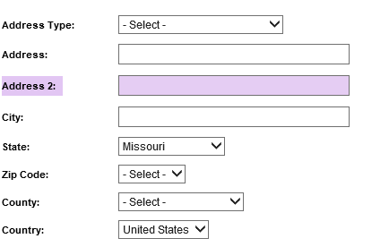

If you have any Case Compass systems questions related to this change, please contact Candy Bohannan by email at [Candy.Bohannan@health.mo.gov](mailto:Candy.Bohannan@health.mo.gov). Policy related questions should be directed to [APSPolicy@health.mo.gov](mailto:APSPolicy@health.mo.gov). Thank you.

TJ/ca