PSEM-20-02

August 21, 2019

MEMORANDUM FOR DIVISION OF SENIOR & DISABILITY SERVICES ADULT PROTECTIVE SERVICES STAFF

From: Kathryn Sharp Sapp, Bureau Chief 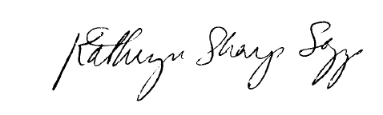
Division of Senior and Disability Services
Adult Protective Services Policy & Staff Development Unit

Subject: Dual Reports

As a result of the upcoming implementation changes for the Special Investigations Unit (SIU) and the Protective Services Unit (PSU), there will be a process change for reports taken at the Central Registry Unit (CRU). The change affects regions that are currently working in the post-implementation system (Regions 1, 4 and 5). Regions 2 and 3 will continue current processes and this time, no changes will be made.

Effective immediately, CRU will no longer create dual reports for cases involving a criminal element and a protective services element and will begin creating one report on these cases going forward.

Process for Regions 1, 4 and 5

CRU will route reports to SIU only on the following reported events:

- Financial Exploitation allegation
- Suspicious Death reports
- EDL reports
All other reports will be classified as a Class I, II or III and routed only to PSU staff. If, during the course of the investigation, PSU staff determine a crime has been committed and SIU staff need to be involved, they will field generate an INV and route to SIU. This determination may require consultation with APCS and SIU staff if questions arise.

This process will be in place until the new implementation plan is effective statewide.

NECESSARY ACTION:
- Review this memorandum with all staff.
- All questions should be cleared through normal supervisory channels and directed to: Amanda Veltrop at APSPolicy@health.mo.gov or by calling 573-526-5391.

TH/KSS/av

