PSEM-19-07

June 21, 2019

MEMORANDUM FOR DIVISION OF SENIOR & DISABILITY SERVICES ADULT PROTECTIVE SERVICES STAFF

From: Kathryn Sharp Sapp, Bureau Chief 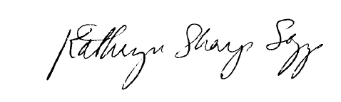
Division of Senior and Disability Services
Adult Protective Services Policy & Staff Development Unit

Subject: Safety Plan

Enhancements to the Adult Protective Services (APS) Manual have been made to update the APS-1: Safety Plan form in section VII of the manual. Following testing through regions implementing Specialized APS, the Safety Plan has been finalized and is now an official state form. The form contains minor layout changes but no content changes from the previous version. This two-part form is being processed through state printing and should be available soon to each region.

NECESSARY ACTION:
- Review this memorandum with all staff.
- Review APS-1: Safety Plan Form
- Review 1707.00: Safety Plan Instructions
- All questions should be cleared through normal supervisory channels and directed to: Amanda Veltrop at APSPolicy@health.mo.gov or by calling 573-526-5391.

KSS/av

