PSEM 19-04

February 11, 2019

**MEMORANDUM FOR SECTION FOR ADULT PROTECTIVE SERVICES STAFF**

From: Kathryn Sharp Sapp, Bureau Chief 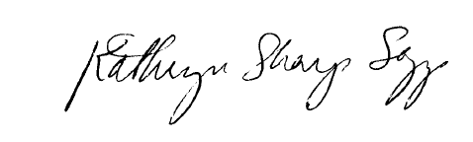

Division of Senior and Disability Services (DSDS)

Adult Protective Services Policy and Training Unit

Subject: Duplicate Reports

Occasionally, duplicative Class I and Class II reports are generated (rather than Class III reports) due to the timing of calls/reports, spelling of names, information given by the reporter, and/or person search issues. As a result, field staff are forced to complete unnecessary work to close the subsequent Class I or Class II reports by closing out all required tasks, assessments, and interventions.

Effective immediately, supervisors are permitted to cancel Class I and Class II reports with the disposition of “Duplicate Report,” when a report is determined to be a duplicate report. Duplicate reports contain information on allegation(s) that have already been reported in an open Class I or Class II report.

The reporter’s information from the duplicate report, including the significant event indicator for financial brokers, shall be added into the involved persons tab on the original report. The narrative from the duplicate report shall be entered into a recording on the original report. The original report and duplicate report shall be cross referenced before the duplicate report is cancelled.

The following is an example of what should be documented in the disposition tab of the duplicate report under the investigative summary field:

This Report is being cancelled as it is a duplicate report to (DA number for the first report). Please refer to (DA number for the first report) for further information.

If there are any questions or concerns that arise they may be directed to the APS Policy Unit email at [APSPolicy@health.mo.gov](mailto:APSPolicy@health.mo.gov) or Michelle Humphrey at 573/526-8502.

MH/KS