PSEM 18-14

August 16, 2018

**MEMORANDUM FOR DIVISION OF SENIOR & DISABILITY SERVICES HOME AND COMMUNITY SERVICES STAFF, CENTRAL REGISTRY UNIT, AND SPECIAL INVESTIGATIONS UNIT**

From: Kathryn Sharp Sapp, Bureau Chief 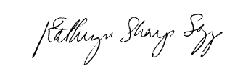

Division of Senior and Disability Services

Adult Protective Services Policy Unit

Subject: Implementation of Specialized Adult Protective Services in Region 4

The journey toward the specialization of adult protective services (APS) continues today with the implementation of Region 4. Effective immediately, Region 4 will begin following policies: 1701.10 – Philosophy; 1702.00 - Intake and Classification; and 1703.10 - Abuse, Neglect and Exploitation Reports. ***As with the implementation of Region 5, staff in remaining regions will continue to operate under existing policy.***

All APS policies and memos associated with the Regions 4 and 5 Implementation will be accessible through the DSDS Resource page by clicking on the Adult Protective Services Staff Information to access the “Specialized APS” button.

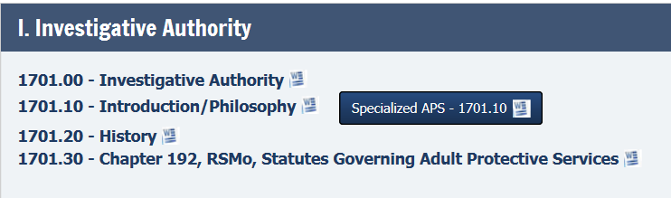

During implementation, CRU will be responsible for generating all intake in Region 4, with the exception of field generated reports under the following circumstances:

1. When it is discovered in the field that there are allegations which are criminal in nature, APS staff shall use the New Intake Screen to create an INV report if there is not a current INV report already assigned to SIU or there is a new alleged perpetrator.
2. When it is determined in the field that a report meets the criteria for an ANE Class I/II/III report, SIU staff shall use the New Intake Screen to create an ANE Class I/II/III report if there is not a current ANE report already assigned to APS.

Since implementation in Region 5, there have been proposed changes to policy based on lessons learned throughout the process. Draft policy is forthcoming and the following summarizes proposed updates:

* Suggested changes in Intake and Classification Policy (1702.00) including:
  + Addition of caregiver “special circumstances” to guide intake staff in determining whether an allegation should be self or caregiver neglect:
* If a person or spouse is not mentally or physically capable of caring for the eligible adult, that person will be documented in Case Compass as an involved person (instead of an alleged perpetrator), and the allegation selected will be Self-Neglect Environmental or Self-Neglect Medical/Physical.
* When an eligible adult is non-responsive or incapacitated and there is indication that another adult (including adult(s) living in the home) has been providing care for the eligible adult, but no caregiver can be identified, the Alleged Perpetrator will be “unknown.”
  + Clarification of “recent” when determining report classification of Sexual and Physical Abuse reports:
* When one or more element is present AND the perpetrator has access within the next 24 hours, the report shall be coded as a Class 1 (emergency).
* When one or more severe element is present AND is happening right now or has occurred within the last 24 hours, the report shall be coded as a Class 1 (emergency).
  + Clarification of emotional abuse allegation:
* If no pattern or effect from the emotional abuse is identified, an IDR will be generated.
* If the emotional abuse rises to the level of a physical threat, the physical abuse allegation should be selected using the indicator “threat to harm.”
  + SIU call out:
* SIU reports are called out when the allegation is “shared” with APS that rises to the level of a Class I report for APS.

Next Steps:

Draft policy, protocols and changes to Case Compass will continue to be evaluated throughout Region 4 implementation to build on successes and address any areas that need improving prior to rolling out to other regions.

The Region 4 Implementation Team, comprised of Angela Davidson APCW, Wendy Rettig APCW, Clevelanda Harwood APCW, Elizabeth Francken APCW, Carol Connor APCS, Ken Campbell APCS, Megan Phillips APCS, Mary Koch ARM, and Teresa Hilker RM, have been meeting throughout the process to help shape policies and protocols. The team will continue to meet throughout the rollout of specialization to evaluate the system changes, policies, and practices.

Special thanks to the Region 5 implementation team for their continued efforts in shaping ongoing implementation activities.

KSS/av