PSEM-17-04

November 14, 2016

MEMORANDUM FOR HOME AND COMMUNITY SERVICES FIELD STAFF
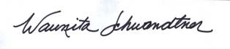
From: Waunita Schwandtner, Bureau Chief
Bureau of Systems & Staff Development

Subject: MO Case Compass Maintenance Release 4.7.2

During Maintenance Release 4.7, the fix applied to “Draft Recordings” inadvertently broke the System Administrator function of deleting recordings. This Maintenance Release restored the System Administrator delete recording function.

Any questions regarding this release should be directed to Candy Bohannan, Case Compass Project Coordinator at Candy.Bohannan@health.mo.gov .

WJAS
CC: Distribution List 2

