PSEM-16-03

December 4, 2015

MEMORANDUM FOR HOME AND COMMUNITY SERVICES FIELD STAFF
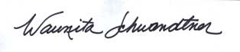
From: Waunita Schwandtner, Bureau Chief
Bureau of Systems & Staff Development

Subject: MO Case Compass Final Conversion (R4.3)

Case Compass Database final conversion of CRANE, CRU Hotline and FRED has been scheduled for implementation this weekend December 5-6, 2015. During the hours of Midnight to 7:00 a.m. CST, Case Compass Database will not be accessible.

Any questions regarding Case Compass Database final conversion should be directed to Waunita Schwandtner, Waunita.Schwandtner@health.mo.gov .

WJAS/CMB
CC: Distribution List 2

