PSEM-16-01

September 29, 2015

MEMORANDUM FOR DIVISION OF SENIOR & DISABILITY SERVICES ADULT PROTECTIVE SERVICES FIELD STAFF
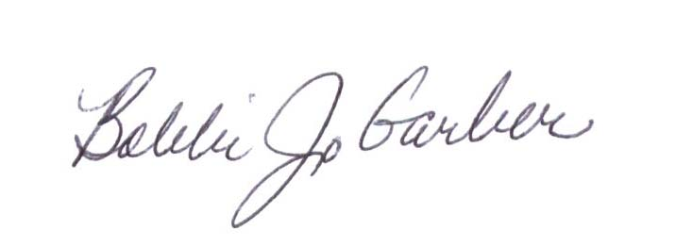

From: Bobbi Jo Garber, Deputy Director
Division of Senior and Disability Services

Subject: Special Investigations Unit and Email address

Effective September 29th, 2015, any referrals for the Special Investigations Unit (SIU), case consultation needs, requests for assistance with obtaining a subpoena, and all other SIU inquiries should be directed to SIU’s newly established email address, SIU@health.mo.gov. The Request for Investigation Form, 1703.30, Exhibit A, should be used when assistance from SIU is being requested.
SIU is responsible for providing investigative assistance to Adult Protective Services (APS) staff with abuse, neglect, and exploitation (ANE) investigations when the situation warrants the need. APS Policy 1703.30 provides direction on situations that may be appropriate for accessing SIU.
SIU investigators Greg Backers, responsible for Regions 1 and 2; EJ Jackson, responsible for Region 3 and the central portion of Region 5; and Mindy Sweezer, responsible for Region 4 and northern Region 5, are currently under the supervision of Kathryn Sapp, Bureau Chief.
SIU will be reaching out to APS supervisors to coordinate and schedule individual and/or unit meetings with APS investigative staff.
This memo has been posted on the DHSS Intranet at the following links: http://dhssnet/seniorservices/psmanual/psemmemos.php.
If you have any questions, please contact the APS Policy Unit via email at APSPolicy@health.mo.gov or by calling 573-526-8537.

BG/KSS/AS

