EM 15-03
PSEM-15-07

March 18, 2015

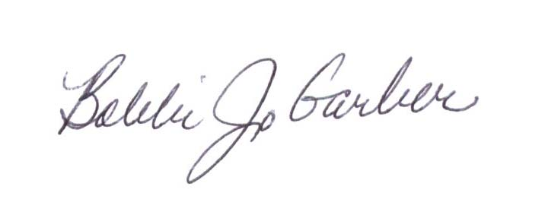
MEMORANDUM FOR HOME AND COMMUNITY SERVICES FIELD STAFF

From: Bobbi Jo Garber, Deputy Director
Division of Senior and Disability Services

Subject: Adult Protective Services Policy Unit and Email Address

Effective March 18th, 2015, all Adult Protective Services (APS) policy questions, Employee Disqualification List (EDL) investigation referrals, questions for the Custodian of Records, and all APS program inquiries should be directed to the APS Policy Unit at APSPolicy@health.mo.gov.
The APS Policy unit is responsible for the writing and updating of all APS policies, the review of all EDL referrals sent to Central Office, and all Custodian of Records responsibilities. Detail on the new APS Policy Revision Process will be forthcoming.
Effective March 1, 2015, APS Policy and Program Support was transitioned from the Bureau of Program Integrity (BPI) to the Bureau of Home and Community Services. Renee Mazurek and Amber Servey, Aging Program Specialists, are now under the supervision of Kathryn Sapp, Bureau Chief.

This memo has been posted on the DHSS Intranet at the following links: http://dhssnet/seniorservices/psmanual/psemmemos.php http://dhssnet/seniorservices/emmemos.php.
If you have any questions, please contact the APS Policy Unit via email at APSPolicy@health.mo.gov.

BG/KSS/AS

