PSEM-15-06

February 27, 2015

MEMORANDUM FOR HOME AND COMMUNITY SERVICES FIELD STAFF
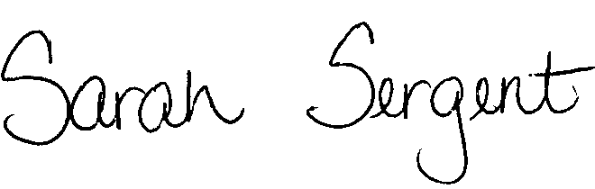
From: Sarah Sergent, Bureau Chief
Bureau of Program Integrity

Subject: Protective Services Employee Memos (PSEM) Link on the Intranet

The Protective Services Employee Memos (PSEM) located in the Adult Protective Services (APS) Manual will now be available on the Intranet under the Manuals and Memos. Staff will be able to access the PSEM’s in the APS manual as well as the new location.

http://dhssnet/seniorservices/

Questions should be directed to the Bureau of Program Integrity at 573/526-8557 or via e-mail at programintegrity@health.mo.gov.

SS
CC: Distribution List 2

