PSEM-15-03

January 21, 2015

MEMORANDUM FOR HOME AND COMMUNITY SERVICES FIELD STAFF
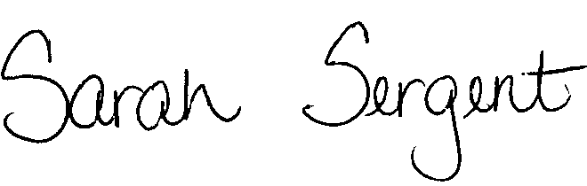

From: Sarah Sergent, Bureau Chief
Bureau of Program Integrity

Subject: Updated Forms/Letters in Case Compass

Adult Protective Services (APS) Forms and Letters, recently updated to reflect statutory changes, are now updated and available for use in the Forms/Letters section of Case Compass. Please see Protective Services Electronic Memo (PSEM) 15-02 for information regarding these changes.
This memo has been posted on the DHSS Intranet at the following link: http://dhssnet/seniorservices/psmanual/psemmemos.php
If you have any questions, please contact the Bureau of Program Integrity at programintegrity@health.mo.gov or at 573-526-8557.

SS/AS

