PSEM-15-02

December 8, 2014

MEMORANDUM FOR HOME AND COMMUNITY SERVICES FIELD STAFF

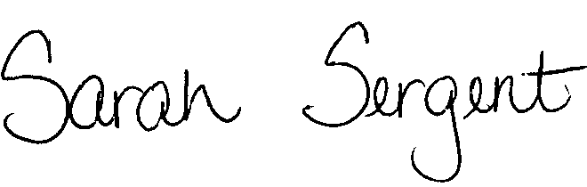
From: Sarah Sergent, Bureau Chief
Bureau of Program Integrity

Subject: Changes to Missouri Revised Statutes

As a result of House Revision Bill (HRB) 1299, the “Division of Aging” and the responsibilities of the division were officially transferred from the Department of Social Services (DSS) to the Department of Health and Senior Services (DHSS), under Article XII, Public Health and Welfare. The transfer impacts many of the statute numbers from which the Division of Senior and Disability Services (DSDS) operates. Previously, Adult Protective Services (APS) statutes were located in Chapter 660. The APS statutes have transferred and can now be found in DHSS Chapter 192.

The Bureau of Program Integrity (BPI) has been working to update all of the statute references within the APS policy manual. Currently, updates to all Exhibit letters throughout the manual and all Forms and instructions in Chapter 7 of the manual have been completed and the updated documents shall be used, effective immediately. BPI will notify APS staff when additional updates have been made. Updates to all Forms/Letters contained in Case Compass are forthcoming.
To search and access the Revised Statutes of Missouri, the new website for the Missouri General Assembly can be found here http://moga.mo.gov/.
This memo has been posted on the DHSS Intranet at the following link: http://dhssnet/seniorservices/psmanual/psemmemos.php.
If you have any questions, please contact the Bureau of Program Integrity at programintegrity@health.mo.gov or at 573-526-8557.

SS/AS

