PSEM-15-01

August 6, 2014

MEMORANDUM FOR HOME AND COMMUNITY SERVICES FIELD STAFF
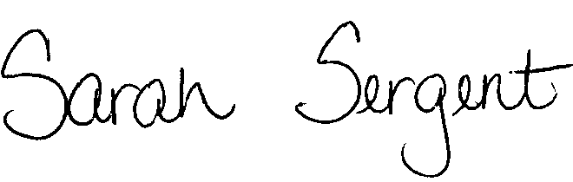

From: Sarah Sergent, Bureau Chief
Bureau of Program Integrity

Subject: Written Notification to Reporter

When a hotline report is received concerning any Home and Community Based Services (HCBS) participant and the allegations involve abuse, neglect, or exploitation (ANE) (including misappropriation and falsification) of the participant by their HCBS provider (employee, aide, personal care attendant, etc.), Section 660.300.10, RSMo requires the Division of Senior and Disability Services (DSDS) to notify the reporter in writing within five (5) working days that the report has been received and the investigation has been started. Adult Protective Services (APS) Policy 1702.70 currently allows APS staff to not send the DA-350 written notification if the reporter has been contacted by phone within three (3) days and the reporter waives the written notification.

The Office of General Counsel (OGC) recently clarified the DA-350 written notification to the reporter. Effective immediately, APS policy shall only allow the waiver of the written notification if the reporter cites a safety concern and feels the written notification may place him or her at risk. Unless the reporter has a safety concern and requests a waiver for this reason, the DA-350 written notification shall be sent to the reporter within five (5) working days for all reports involving ANE of HCBS participants by their HCBS provider. The policy revision is forthcoming.

The DA-350 written notification is not required for hotline reports that do not involve HCBS participants and HCBS provider staff.

This memo will be posted on the DHSS Intranet at the following link: http://dhssnet/seniorservices/psmanual/psemmemos.php
If you have any questions, please contact the Bureau of Program Integrity at programintegrity@health.mo.gov or at 573-526-8557.

SS/AS

