PSEM-14-06

January 24, 2014

MEMORANDUM FOR HOME AND COMMUNITY SERVICES FIELD STAFF

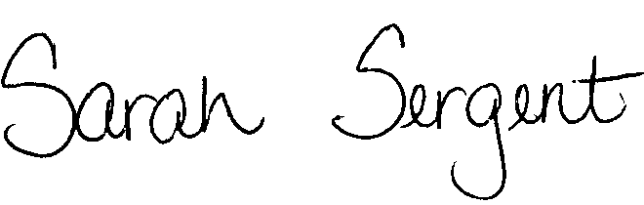
From: Sarah Sergent, Bureau Chief
Bureau of Program Integrity

Subject: Updates to Forms/Letters in Case Compass

All documents contained in the Forms/Letters section of Case Compass were reviewed and all necessary updates have been completed. Documents on letterhead in Case Compass have been revised as a result of the new department director appointment. The latest versions of forms were added and any duplicate or obsolete documents have been removed. All documents in the Forms/Letters section of Case Compass are available for use.
This memo has been posted on the DHSS Intranet at the following link: http://dhssnet/seniorservices/psmanual/psemmemos.php
If you have any questions, please contact the Bureau of Program Integrity at programintegrity@health.mo.gov or at 573-526-8557.

SS/AS

