PSEM-14-02

November 6, 2013

MEMORANDUM FOR HOME AND COMMUNITY SERVICES FIELD STAFF

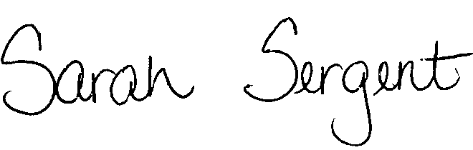
From: Sarah Sergent, Bureau Chief

Division of Senior and Disability Services

Subject: Lottery Scams
Lottery scams are becoming more and more prevalent in our society today. The most recent lottery scam is the Jamaican Lottery Scam. Originating out of Jamaica, our local law officials have no jurisdiction in this particular crime.
Scammers can prey on anyone, and often, vulnerable seniors fall victim to this crime. When DSDS receives a report involving a lottery scam, the APCW should gather as much information from the reporter to determine if additional issues are affecting the life and financial status of the reported adult. If additional issues regarding a protective service need are found, the APCW shall generate a report in Case Compass.
If the main report issue involves only that the RA fell victim to a lottery scam, the APCW may refer the individual to the Consumer Fraud Task Force. If a referral is made, the APCW shall not share an RA’s personal information with members of the Task Force. It shall be the responsibility of the RA to provide the information directly to the Task Force.
The Task Force is a coalition of local, state and federal government agencies, nonprofit businesses, and consumer groups in Missouri and Illinois that work together to protect consumer and donor rights and guard against fraud.
To obtain information, or to report a scam, individuals may contact any of the following members of the Task Force:
Better Business Bureau Serving Eastern Missouri – (314) 645-3300; http://www.bbb.org/
Federal Trade Commission – (877) FTC-HELP (382-4357); http://www.ftc.gov
Missouri Attorney General – (800) 392-8222; http://www.ago.mo.gov
U.S. Attorney, Eastern District of Missouri – (314) 539-2200; http://www.usdoj.gov/usao/moe
U.S. Postal Inspection Service – (877) 876-2455; http://www.postalinspectors.uspis.gov
U.S. Secret Service – (314) 539-2238; http://www.secretservice.gov
Better Business Bureau in Greater Kansas City – (816) 421-7800; http://www.bbb.org/
Other task force members include:
- Federal Bureau of Investigation
- Missouri Secretary of State, Securities Division
- Better Business Bureau in Southwest Missouri
- Legal Services of Eastern Missouri
- Legal Services of Southern Missouri
- Legal Services of Western Missouri
- Mid-Missouri Legal Services
This memo has been posted on the DHSS Intranet at the following link: http://dhssnet/seniorservices/psmanual/psemmemos.php.
If you have any questions, please contact the Bureau of Program Integrity at programintegrity@health.mo.gov or at 573-526-8557.

SS/MF/TH

