PSEM-13-06

June 27, 2013

MEMORANDUM FOR HOME AND COMMUNITY SERVICES FIELD STAFF

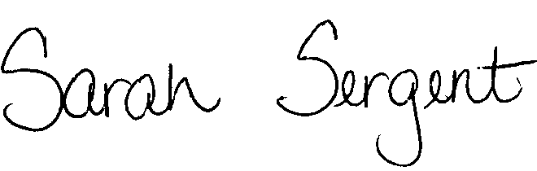
From: Sarah Sergent, Bureau Chief
Bureau of Program Integrity

Subject: Record Request Questions

All questions regarding record requests should only be directed to the Custodian of Records (COR) in Central Office. The COR is able to address policy questions as well as seek input from the Office of General Counsel (OGC) when needed and relay the response to the supervisor or Adult Protective Community Worker (APCW) as appropriate. Directing questions only to the COR will allow for the consistent interpretation and application of policy.
This memo has been posted on the DHSS Intranet at the following link: http://dhssnet/seniorservices/psmanual/psemmemos.php
If you have any questions, please contact the Bureau of Program Integrity at programintegrity@health.mo.gov or at 573-526-8557.

SS/MF

