PSEM-13-05

April 15, 2013

MEMORANDUM FOR HOME AND COMMUNITY SERVICES FIELD STAFF

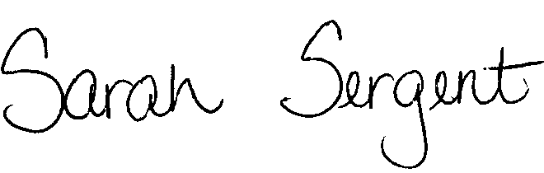
From: Sarah Sergent, Bureau Chief
Bureau of Program Integrity

Subject: Information Request Letter

The Information Request Letter (Policy 1703.20, Exhibit C) is utilized when requesting protected health information (PHI) from a medical entity as part of an investigation. It explains that HIPAA waives the privacy rule under these circumstances. This letter is now available in the online manual as a fillable document.

This memo has been posted on the DHSS Intranet at the following link: http://dhssnet/seniorservices/psmanual/psemmemos.php
If you have any questions, please contact the Bureau of Program Integrity at programintegrity@health.mo.gov or at 573-526-8557.

SS/MF

