EM-13-06
PSEM-13-04

January 9, 2013

MEMORANDUM FOR HOME AND COMMUNITY SERVICES FIELD STAFF
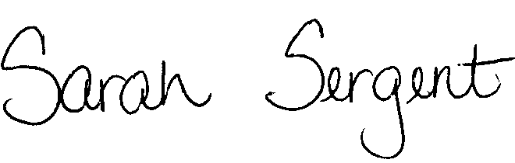

From: Sarah Sergent, Bureau Chief
Bureau of Program Integrity

Subject: Staffing Hours of the Central Registry Unit

Effective January 14th, 2013, the Central Registry Unit (CRU) hours of operation will change. CRU will now be staffed from 7:00 AM to 12:00 AM, seven days a week, including all holidays.
Calls made to CRU after close of business will receive a message directing emergency calls to 911. All other calls shall be directed to contact CRU the following day during regular business hours.
The memo is posted on the DHSS Intranet at: http://dhssnet/seniorservices/emmemos.php and http://dhssnet/seniorservices/psmanual/psemmemos.php.
If you have any questions, please contact the Bureau of Program Integrity at programintegrity@health.mo.gov or at 573-526-8557.

AS/SS

CC: Distribution List 1 & 2

