PSEM-13-03

December 17, 2012

MEMORANDUM FOR HOME AND COMMUNITY SERVICES FIELD STAFF
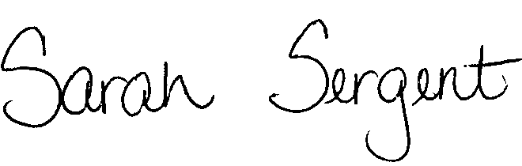

From: Sarah Sergent, Bureau Chief
Bureau of Program Integrity

Subject: Response to Provider on EDL Reviews

When a provider agency reports an allegation involving their in-home staff as the alleged perpetrator (AP), and the investigation of the allegation may lead to a referral for administrative review and possible inclusion on the Employee Disqualification List (EDL), the provider has a valid need to know when the investigation has been concluded and whether or not the investigation was referred for administrative review and possible EDL inclusion.

In all cases in which a provider is the reporter of the allegations, Adult Protective Services (APS) staff should follow-up by sending the standardized letter, 1703.72 Exhibit C, to the provider when the investigation is complete. If an inquiry is made by a provider who was not the reporter of the allegations, the standardized letter, 1703.72, Exhibit C, shall be sent at the conclusion of the investigation. The policy revision to 1703.72 is forthcoming.

APS staff should indicate in the letter whether the investigation “Has” or “Has Not” been submitted to Central Office for administrative review and possible EDL inclusion. As directed in PSEM-13-02, APS staff will only use policy documents/forms containing letterhead found in the online APS manual.

This memo has been posted on the DHSS Intranet at the following link: http://dhssnet/seniorservices/psmanual/psemmemos.php
If you have any questions, please contact the Bureau of Program Integrity at programintegrity@health.mo.gov or at 573-526-8557.

AS/MF/SS

