PSEM-13-02

December 17, 2012

MEMORANDUM FOR HOME AND COMMUNITY SERVICES FIELD STAFF

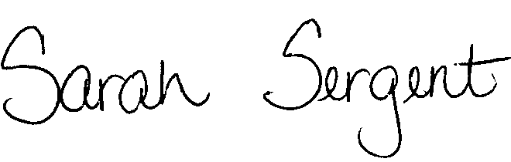
From: Sarah Sergent, Bureau Chief
Bureau of Program Integrity

Subject: Changes to the Letterhead on Adult Protective Services Documents/Forms

Effective December 10, 2012, the Division of Senior and Disability Services was informed that Gail Vasterling has been appointed Acting Director and all department letterhead shall reflect this. In response, the Bureau of Program Integrity (BPI) has revised the letterhead of online documents/forms in the Adult Protective Services (APS) manual.

Documents/forms on letterhead found in Case Compass will be revised at a later date. Until further notice, APS staff will only use policy documents/forms containing letterhead found in the online APS manual.

This memo and the revised forms have been posted on the DHSS Intranet at the following link: http://dhssnet/seniorservices/psmanual/
If you have any questions, please contact BPI at programintegrity@health.mo.gov or at 573-526-8557.

LS//MF/SS

