Download the DA7 from either the Case Management or APS manuals on the intranet and save it. Open the DA7 then go to the Tools menu and scroll down to Macro Security
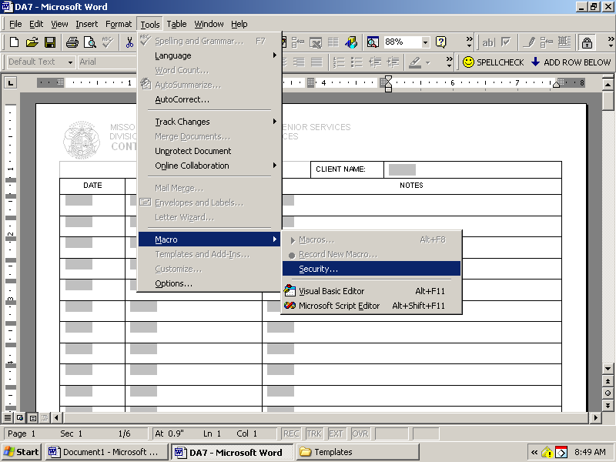

Set the Security Level to Medium
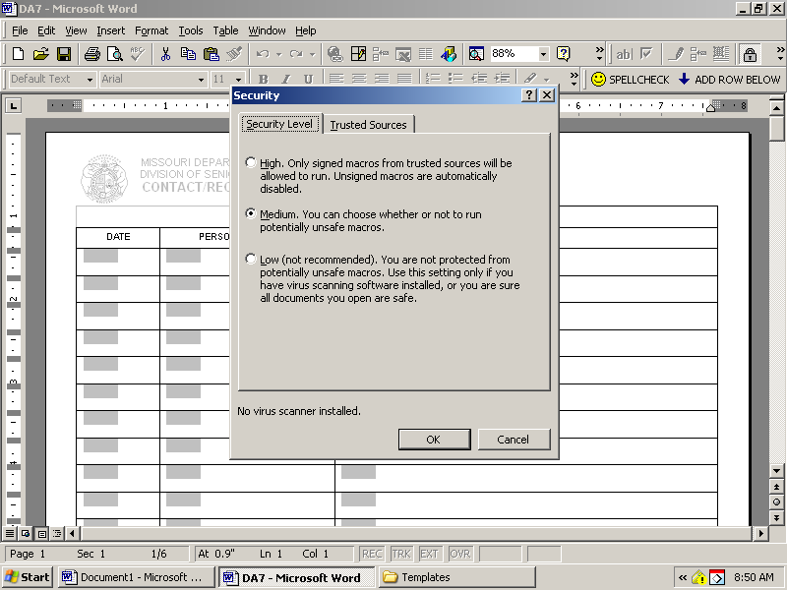

Close out the document without saving and reopen it
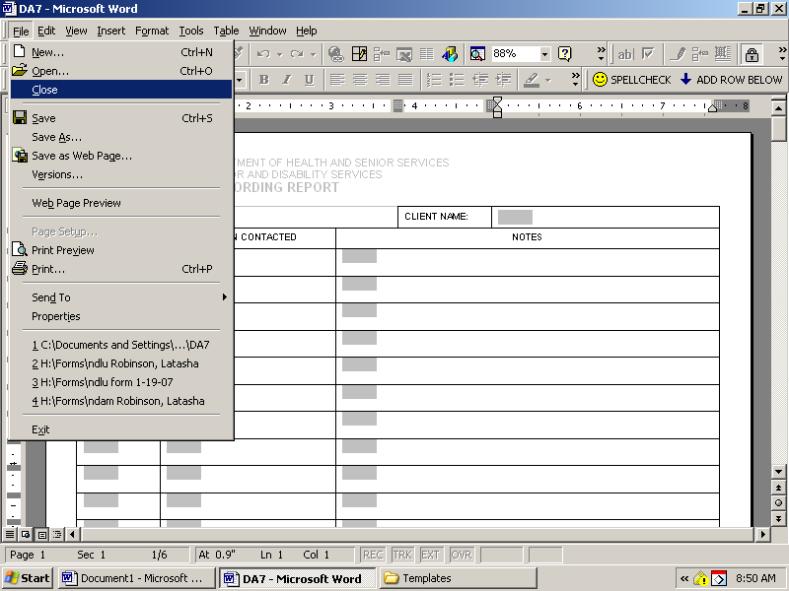

The enable macros screen should appear 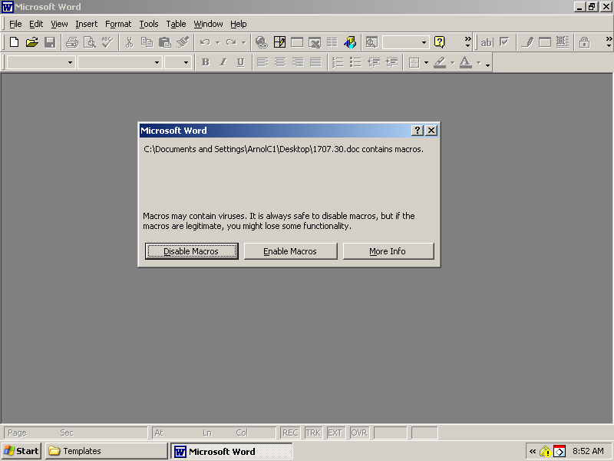

PLEASE enable the macros or the spell check and add a row functions will not run. You will have to enable the macros every time you use this DA7.
Remember that the toolbar is changeable and you can close down all the toolbars by unchecking them until only the Help Functions tool bar remains
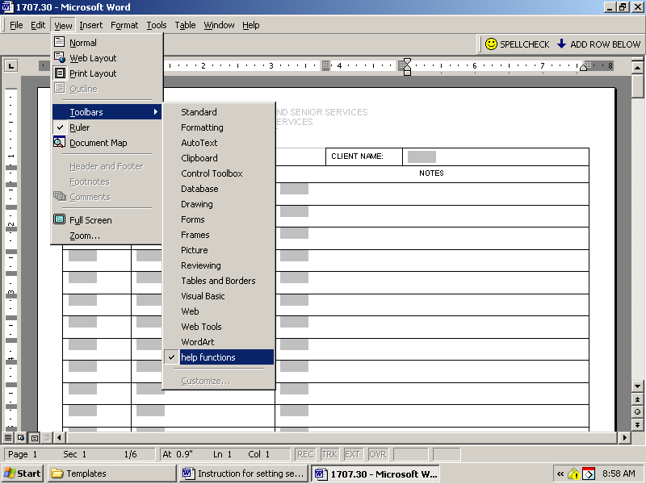

To add a row below, highlight the text field in the row above the insertion point
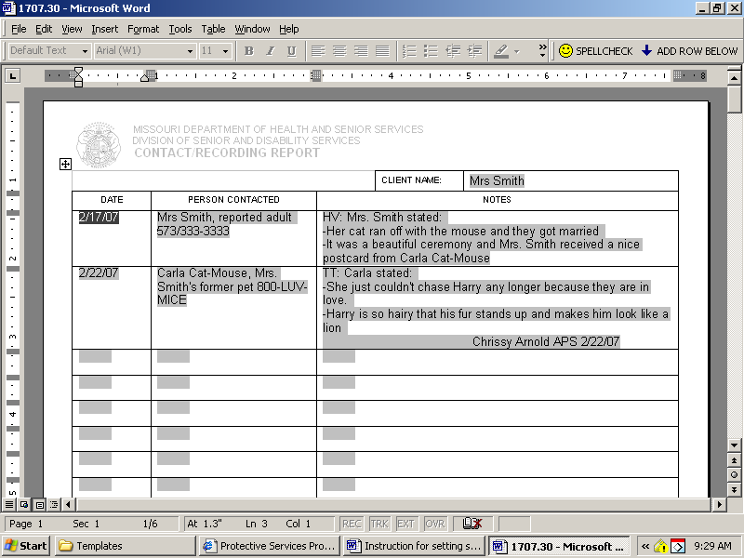

Then click the add row below button. The “add a new row?” help screen will appear.
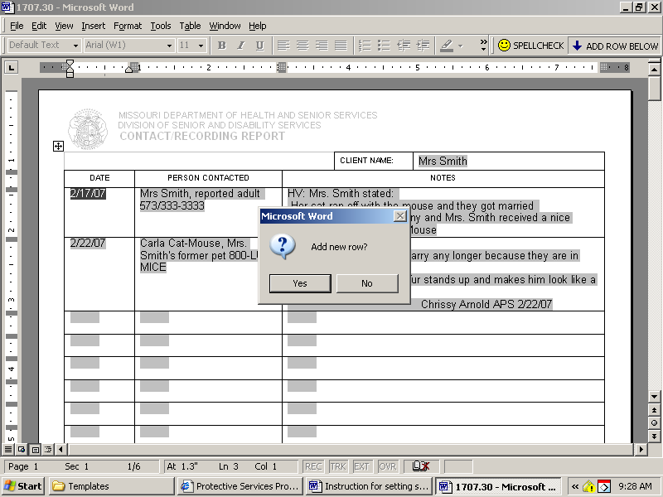

Click yes and a new row should appear below the row you selected
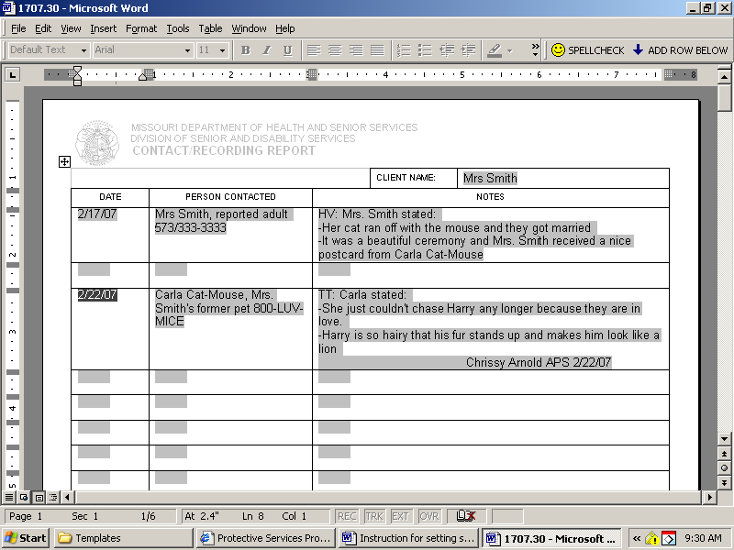
REMEMBER to look at the where the row is going before clicking yes because the new row cannot be deleted once added.

