Open the DA-7 form

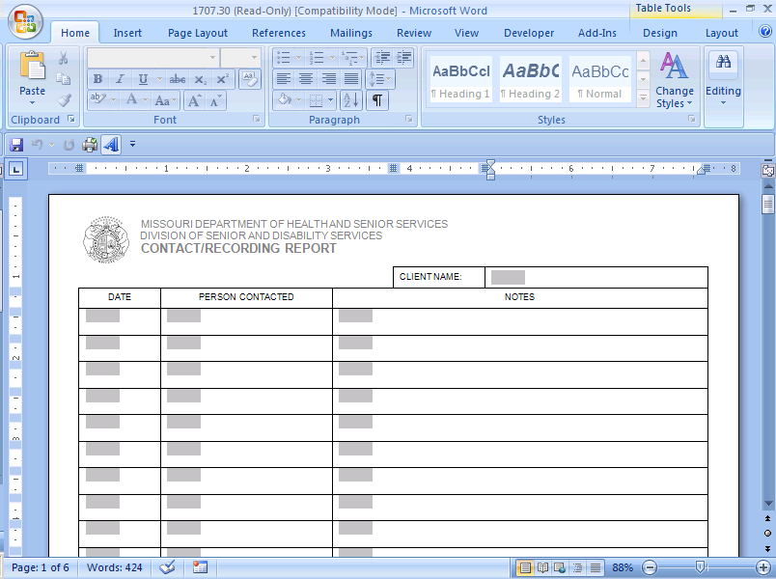

As needed, click on “Security Warning” Macro options.

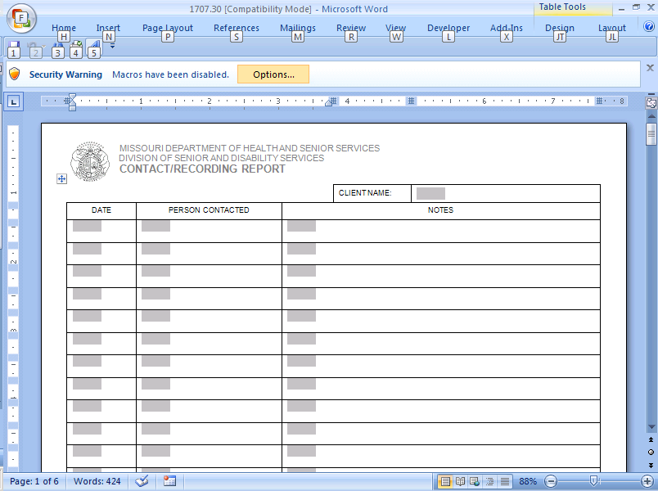

Enable the content and save the form.

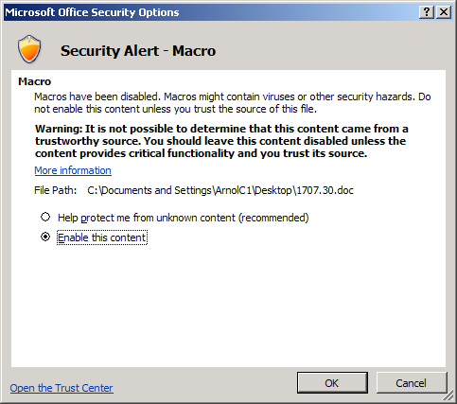

The Spell check and Add a row features are located in the Add-Ins tab. To utilize these features, click on either one.

