APS-18-05

May 9, 2018

**MEMORANDUM FOR DIVISION OF SENIOR & DISABILITY SERVICES ADULT PROTECTIVE SERVICES STAFF**

From: Kathryn Sharp Sapp, Bureau Chief 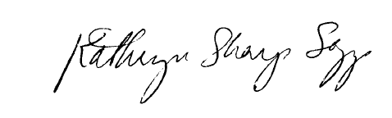

Division of Senior and Disability Services

Adult Protective Services Policy Unit

Subject: Use of Personal Mobile Devices for Official State Business

Enhancements to the Adult Protective Services (APS) Manual have been made to include a policy on the use of mobile devices, including a personal mobile device, for official state business. This policy has been developed following employee feedback regarding the use of such devices.

This policy references State of Missouri Administrative Policy [SP-3: Wireless Telephone Equipment and Services Usage](https://www.google.com/url?sa=t&rct=j&q=&esrc=s&source=web&cd=3&cad=rja&uact=8&ved=0ahUKEwiPxvKP9PvaAhVV1IMKHaH1BSIQFggyMAI&url=https%3A%2F%2Foa.mo.gov%2Fsites%2Fdefault%2Ffiles%2Fwireless_usage.pdf&usg=AOvVaw2dmTiwtFF9BXT5MiBwqEqd) and Department of Health and Senior Services Administrative Policy [11.2: Personal Telecommunications](http://dhssnet/policiesprocedures/doc/adminmanual11_2.doc). While the use of personal mobile devices for official state business is discouraged, there are utilizations that may be necessary to perform job duties safely and efficiently. This addition to policy outlines the appropriate use of personal devices.

**NECESSARY ACTION:**

1. Review this memorandum with all APS staff.
2. Review revised APS Policy [1705.55](https://health.mo.gov/seniors/apsmanual/doc/1705.55.doc): Mobile Devices.
3. All questions should be cleared through normal supervisory channels and directed to: Amanda Veltrop at [APSPolicy@health.mo.gov](mailto:APSPolicy@health.mo.gov) or by calling 573-526-5391.

**APS Manual Revisions:**

APS Policy [1705.55](https://health.mo.gov/seniors/apsmanual/doc/1705.55.doc): Mobile Devices– Policy added