APS-18-04

May 4, 2018

**MEMORANDUM FOR DIVISION OF SENIOR & DISABILITY SERVICES**

**ADULT PROTECTIVE SERVICES STAFF**

From: Kathryn Sharp Sapp, Bureau Chief 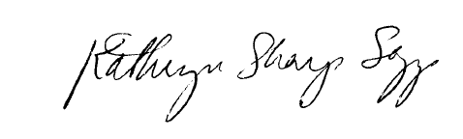

Division of Senior and Disability Services

Adult Protective Services Policy Unit

Subject: Case Record Retention

Enhancements to the Adult Protective Services (APS) Manual have been made to provide clarity on the Division of Senior and Disability Service’s APS case record retention policy to be consistent with Home and Community Based Services record retention policy.

The previous retention policy included information on the composition of the case record. This information was eliminated from 1706.10, and has been incorporated into policy 1706.20: Documentation.

**NECESSARY ACTION:**

1. Review this memorandum with all APS staff.
2. Review revised APS Policy 1706.10: Case Record Retention.
3. All questions should be cleared through normal supervisory channels and directed to: Amanda Mabey or Michelle Humphrey at [APSPolicy@health.mo.gov](mailto:APSPolicy@health.mo.gov) or by calling 573-526-5391/573-526-8502.

**APS Manual Revisions:**

APS Policy 1706.10: Case Record Retention – Policy title change and manual revisions.