APS-18-01
October 31, 2017

MEMORANDUM FOR DIVISION OF SENIOR & DISABILITY SERVICES ADULT PROTECTIVE SERVICES STAFF AND REGIONAL MANAGERS

From: Kathryn Sharp Sapp, Bureau Chief 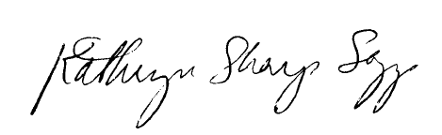
Division of Senior and Disability Services
Adult Protective Services Policy Unit

Subject: Sexual Offender Registry (SOR) checks

It was brought to the attention of the Adult Protective Services Policy Unit that the SOR inquiry function in Case Compass is not currently functioning as needed. The Bureau of Automation, Data Analysis & Training is working with Information Technology Services Division to resolve the issue. Effective immediately, Central Registry Unit staff shall manually check the SOR for all Class I reports and BHCS staff shall check for Class II reports and Information Detail Requests.

NECESSARY ACTION:
- Review this memorandum with all staff.
- All questions should be cleared through normal supervisory channels and directed to:
APSPolicy@health.mo.gov or by calling Amanda Veltrop at (573) 526-5391.

