APS-15-03

January 13, 2015

MEMORANDUM FOR HOME AND COMMUNITY SERVICES FIELD STAFF

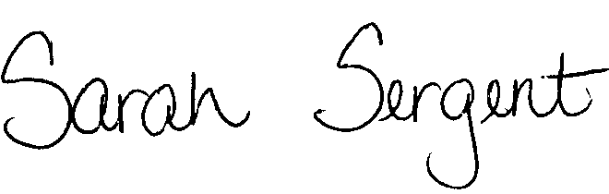
From: Sarah Sergent, Bureau Chief
Bureau of Program Integrity

Subject: Missouri Revised Statute Reference Updates

Adult Protective Services (APS) Manual
Please see Protective Services Electronic Memo (PSEM) 15-02 regarding the following policy changes:

1700.00-1700.10 Statutory references were updated as a result of House Revision Bill (HRB) 1299.
1701.10-1701.80 Statutory references were updated as a result of House Revision Bill (HRB) 1299.
1702.00-1702.90 Statutory references were updated as a result of House Revision Bill (HRB) 1299.
1703.00-1703.80 Statutory references were updated as a result of House Revision Bill (HRB) 1299.
1704.40-1704.46 Statutory references were updated as a result of House Revision Bill (HRB) 1299.
1706.50 Statutory references were updated as a result of House Revision Bill (HRB) 1299.
This memo has been posted on the DHSS Intranet at the following link: http://dhssnet/seniorservices/psmanual/memos.php.
If you have any questions, please contact the Bureau of Program Integrity at programintegrity@health.mo.gov or at 573-526-8557.

The policy revisions are effective upon receipt.

SS/AS/MS

