APS-15-02

October 24, 2014

MEMORANDUM FOR HOME AND COMMUNITY SERVICES FIELD STAFF

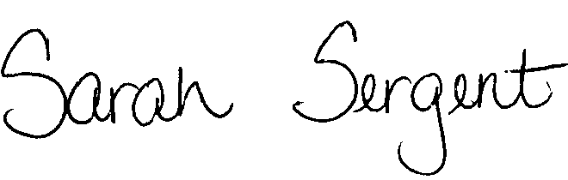

From: Sarah Sergent, Bureau Chief

Division of Senior and Disability Services

Subject: Revised Policy Regarding Classification of Reports and Class I Report Examples

Adult Protective Services (APS) Manual
1702.60 | Policy has been updated to clarify the appropriate classification of all Abuse, Neglect, and Exploitation (ANE) reports received by the Division of Senior and Disability Services (DSDS). Policy was revised to provide updated information and direction regarding the tracking and classification of non-ANE reports received by DSDS. Hyperlinks have been added to the policy to provide ease of access to statutes and other APS policies referenced within the policy.
1702.60  Appendix A | Policy was revised to include Endangered Persons/Silver Alerts on the Appendix which contains a list of Class I report examples. The updated Appendix clarifies the situations which would meet the DSDS criteria for Class I. Hyperlinks have been added to provide ease of access to APS policies referenced within the Appendix.

This memo has been posted on the DHSS Intranet at the following link: http://dhssnet/seniorservices/psmanual/memos.php.
If you have any questions, please contact the Bureau of Program Integrity at programintegrity@health.mo.gov or at 573-526-8557.

SS/WB/AS

