APS-15-01

September 16, 2014

MEMORANDUM FOR HOME AND COMMUNITY SERVICES FIELD STAFF

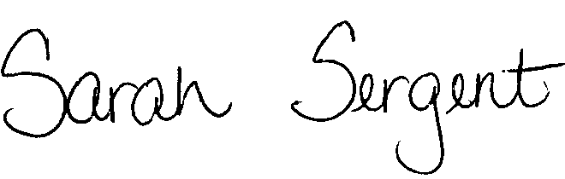

From: Sarah Sergent, Bureau Chief

Division of Senior and Disability Services

Subject: Revised Policy Regarding Referral Process

Adult Protective Services (APS) Manual
1703.72 | Policy has been revised to provide updated information, direction, and language for concluding and referring Abuse, Neglect, and Exploitation (ANE) investigations to law enforcement, the local prosecutor, and the Employee Disqualification List (EDL). Hyperlinks have been added to provide ease of access to needed DA forms and other APS policies referenced within the policy.
1703.72  Exhibit C Ccc C C | The Response to Provider on EDL Investigative Findings letter, 1703.72, Exhibit C, has been removed from policy per direction from the Office of General Counsel (OGC). The letter is obsolete and shall no longer be utilized.
DA-24 | The Investigation Conclusion Notification letter, the DA-24, is a new DA form letter added to policy. Policy 1703.72 contains information and direction for sending the DA-24 letter.
1707.58 | Instructions for completing the DA-24 have been added to policy.
This memo has been posted on the DHSS Intranet at the following link: http://dhssnet/seniorservices/psmanual/memos.php.
If you have any questions, please contact the Bureau of Program Integrity at programintegrity@health.mo.gov or at 573-526-8557.

SS/AS

