APS-14-12

May 23, 2014

MEMORANDUM FOR HOME AND COMMUNITY SERVICES FIELD STAFF

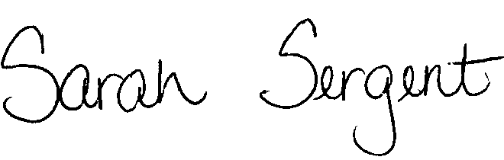
From: Sarah Sergent, Bureau Chief
Bureau of Program Integrity

Subject: Revised Policy Regarding Adults in Facilities

Adult Protective Services (APS) Manual
1702.15 Policy has been revised to provide updated information, language, and direction regarding the investigation of Abuse, Neglect, and Exploitation (ANE) of eligible adults occurring within a facility setting. Additionally, hyperlinks have been added to provide ease of access to other APS policies and divisions/agencies referenced within the policy.
This memo has been posted on the DHSS Intranet at the following link: http://dhssnet/seniorservices/psmanual/memos.php.
If you have any questions, please contact the Bureau of Program Integrity at programintegrity@health.mo.gov or at 573-526-8557.

The policy revisions are effective upon receipt.

SS/AS

