APS-14-11

April 9, 2014

MEMORANDUM FOR HOME AND COMMUNITY SERVICES FIELD STAFF

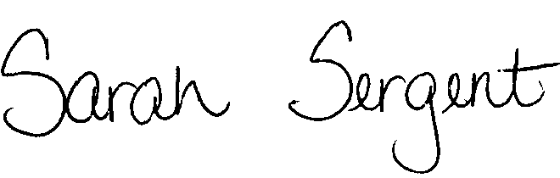
From: Sarah Sergent, Bureau Chief
Bureau of Program Integrity

Subject: Content of Reports
Adult Protective Services (APS) Manual
1702.50 Policy has been revised to provide clarification on the necessary information to be gathered and included in the content of Abuse, Neglect, and Exploitation (ANE) reports. The policy revision incorporates current language and provides direction regarding current systems used for the intake of ANE reports.
This memo has been posted on the DHSS Intranet at the following link: http://dhssnet/seniorservices/psmanual/memos.php.
If you have any questions, please contact the Bureau of Program Integrity at programintegrity@health.mo.gov or at 573-526-8557.

The policy revisions are effective upon receipt.

SS/AS

