APS-14-10

March 6, 2014

MEMORANDUM FOR HOME AND COMMUNITY SERVICES FIELD STAFF

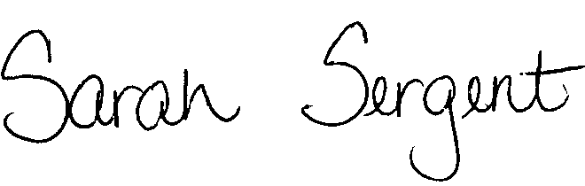
From: Sarah Sergent, Bureau Chief
Bureau of Program Integrity

Subject: Participant-Consumer Falsification and Fraud

Adult Protective Services (APS) Manual
1703.24 Policy has been revised to provide clarification on the handling of investigations that involve participant falsification and fraud and to provide direction on the process for referring and exchanging information with the Missouri Medicaid Audit and Compliance Unit (MMAC).
1703.24 Participant Falsification and Fraud MMAC Referral to Investigations form has Exhibit A been revised and condensed.
This memo has been posted on the DHSS Intranet at the following link: http://dhssnet/seniorservices/psmanual/memos.php.
If you have any questions, please contact the Bureau of Program Integrity at programintegrity@health.mo.gov or at 573-526-8557.

The policy revisions are effective upon receipt.

SS/AS

