APS-14-09

March 6, 2014

MEMORANDUM FOR HOME AND COMMUNITY SERVICES FIELD STAFF

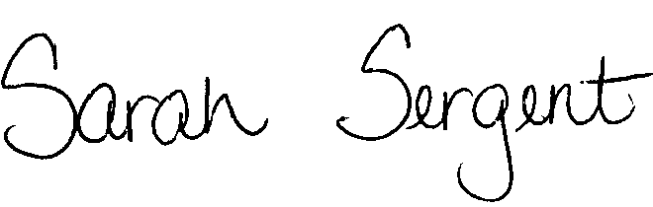
From: Sarah Sergent, Bureau Chief
Bureau of Program Integrity

Subject: APS Legal Review Form and Instructions

Adult Protective Services (APS) Manual
1707.55 The DA-22 and instructions have been revised to include additional case pedigree information.

Chapter 7 The revision dates for the DA-22 and 1707.55 were updated on the summary.
Summary

This memo has been posted on the DHSS Intranet at the following link: http://dhssnet/seniorservices/psmanual/memos.php.
If you have any questions, please contact the Bureau of Program Integrity at programintegrity@health.mo.gov or at 573-526-8557.

The policy revisions are effective upon receipt.

SS/TH

