APS-14-07

February 19, 2014

MEMORANDUM FOR HOME AND COMMUNITY SERVICES FIELD STAFF
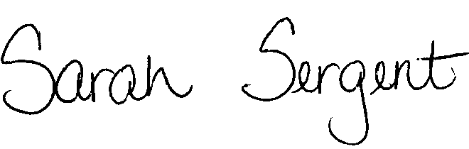

From: Sarah Sergent, Bureau Chief
Bureau of Program Integrity

Subject: 1701.10 Introduction/Philosophy Revised

Adult Protective Services (APS) Manual
1701.10 The Introduction/Philosophy has been updated to reflect the Department of Health and Senior Services and, specifically, the Division of Senior and Disability Services mission statements.
This memo has been posted on the DHSS Intranet at the following link: http://dhssnet/seniorservices/psmanual/memos.php.
If you have any questions, please contact the Bureau of Program Integrity at programintegrity@health.mo.gov or at 573-526-8557.

The policy revisions are effective upon receipt.

SS/TH

