APS-14-06

January 16, 2014

MEMORANDUM FOR HOME AND COMMUNITY SERVICES FIELD STAFF
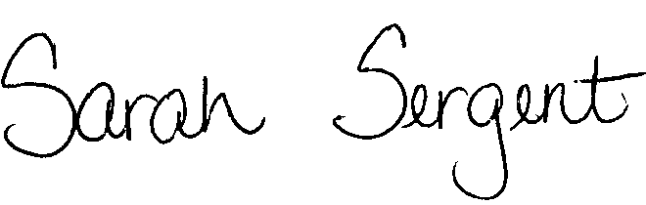

From: Sarah Sergent, Bureau Chief
Bureau of Program Integrity

Subject: Adult Protective Services Manual Revisions

Adult Protective Services (APS) Manual
1702.90 Policy has been revised to provide a brief summary regarding the Employee Disqualification List including what it is and who is included on the list.

This memo has been posted on the DHSS Intranet at the following link: http://dhssnet/seniorservices/psmanual/memos.php.
If you have any questions, please contact the Bureau of Program Integrity at programintegrity@health.mo.gov or at 573-526-8557.

The policy revisions are effective upon receipt.

SS/MF/TH

