APS-14-04

November 18, 2013

MEMORANDUM FOR HOME AND COMMUNITY SERVICES FIELD STAFF

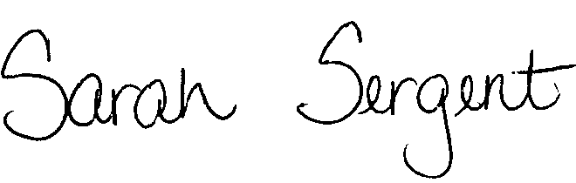
From: Sarah Sergent, Bureau Chief
Bureau of Program Integrity

Subject: Adult Protective Services Manual Revisions

Adult Protective Services (APS) Manual
1703.22 Policy has been revised to clarify the needed documentation to develop a thorough EDL evidence profile and the terms used during an EDL investigation regarding the possible statutory violations.

This memo has been posted on the DHSS Intranet at the following link: http://dhssnet/seniorservices/psmanual/memos.php.
If you have any questions, please contact the Bureau of Program Integrity at programintegrity@health.mo.gov or at 573-526-8557.

The policy revisions are effective upon receipt.

SS/MF/TH

