APS-14-03

October 30, 2013

MEMORANDUM FOR HOME AND COMMUNITY SERVICES FIELD STAFF
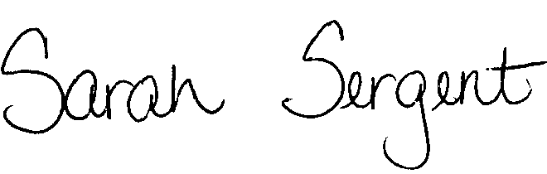

From: Sarah Sergent, Bureau Chief
Bureau of Program Integrity

Subject: Adult Protective Services Manual Revisions

Adult Protective Services (APS) Manual
1702.40 Policy has been revised to clarify the definitions of abuse, neglect, financial exploitation, misappropriation of funds and falsification of documentation and to provide a brief summary regarding referrals under each definition.

The memorandum has been posted on the DHSS Intranet at the following link: http://dhssnet/seniorservices/psmanual/memos.php.
If you have any questions, please contact the Bureau of Program Integrity at programintegrity@health.mo.gov or at 573-526-8557.

The policy revision are effective upon receipt.

SS/MF/TH

