APS-14-02

October 29, 2013

MEMORANDUM FOR HOME AND COMMUNITY SERVICES FIELD STAFF

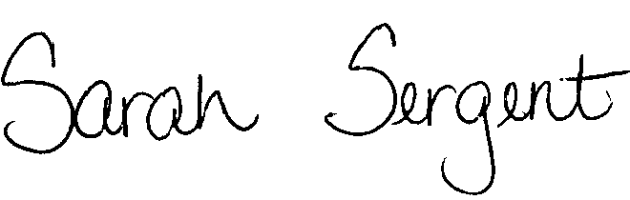
From: Sarah Sergent, Bureau Chief
Bureau of Program Integrity

Subject: Adult Protective Services Manual Revisions

Adult Protective Services (APS) Manual
1702.70 Policy has been revised to provide direction and clarification on responsibilities and time frames for processing ANE reports and updating information in Case Compass. The policy revision provides direction on procedures for handling Class I reports during and after hours. Policy has been revised to provide updated Case Compass system language as well as Case Compass requirements for ANE reports and the Reporter Notification letter.

The memorandum has been posted on the DHSS Intranet at the following link: http://dhssnet/seniorservices/psmanual/memos.php.
If you have any questions, please contact the Bureau of Program Integrity at programintegrity@health.mo.gov or at 573-526-8557.

The policy revisions are effective upon receipt.

SS/MF/AS

