APS-14-01

October 11, 2013

MEMORANDUM FOR HOME AND COMMUNITY SERVICES FIELD STAFF
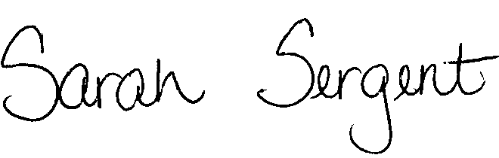

From: Sarah Sergent, Bureau Chief
Bureau of Program Integrity

Subject: Adult Protective Services Manual Revisions

Adult Protective Services (APS) Manual
1707.60 The HIPAA Acknowledgement Form has been added to forms and the instructions revised to address the need for documentation of compliance with HIPAA regulations when providing protective services.

1707.61 The Authorization for Disclosure of Consumer Medical/Health Information Form has been added to forms and the instructions revised to address the need for documentation of compliance with HIPAA regulation when providing protective services.

Chapter 7 The summary of forms has been revised to include the HIPAA Acknowledgement
Summary Form and the Authorization for Disclosure of Consumer Medical/Health Information Form.

This memo has been posted on the DHSS Intranet at the following link: http://dhssnet/seniorservices/psmanual/memos.php.
If you have any questions, please contact the Bureau of Program Integrity at programintegrity@health.mo.gov or at 573-526-8557.

The policy revisions are effective upon receipt.

SS/MF/TH

