APS-13-08

May 1, 2013

MEMORANDUM FOR HOME AND COMMUNITY SERVICES FIELD STAFF

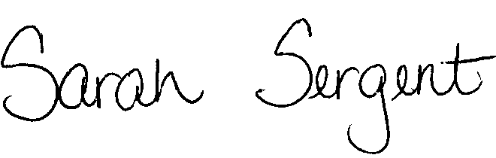
From: Sarah Sergent, Bureau Chief
Bureau of Program Integrity

Subject: Adult Protective Services Manual Revisions

Adult Protective Services (APS) Manual
1703.64 Policy has been revised to provide clarification on how and when to assess risk, reflect changes to documentation of the Risk Assessment and provide information on the updates and requirements to the Risk Assessment being implemented in Case Compass.
1703.70 The Appendix has been updated to reflect system changes implemented as a result Appendix A of Case Compass.
This memo has been posted on the DHSS Intranet at the following link: http://dhssnet/seniorservices/psmanual/psemmemos.php
If you have any questions, please contact the Bureau of Program Integrity at programintegrity@health.mo.gov or at 573-526-8557.

The policy revisions are effective upon receipt.

SS/MF/AS

